PIMA Bulletin No 39 November 2021

Climate Justice and Adult Learning and Education (ALE)
Contents
Guest Editor
Shirley Walters……………………………………………………………………………….2
Poem: My response to Corona Virus
Serap Brown ….…….……………………………………….5
Contexts and concepts
- Climate justice and the Knowledge Action Agenda: Jim Falk…………………...……………6
- Climate justice and transformative lifelong learning: Shirley Walters and Jane Burt … 9
- Ecofeminist popular education: Mela Chiponda……………...……………………………....12
- Joining the dots: Transformative resilience for climate justice: Astrid von Kotze……...…...16
- Climate Justice Charter in South Africa: Vishwas Satgar……………………………………18

What works and lessons learnt
- What works and lessons learned: Adult learners’ engagement with climate crisis: Joy Polanco O’Neil and Shauna Butterwick …………………………………………………………21
- Environmental adult education through the arts: Darlene Clover, Victoria Foster and Joy Polanco O’Neil ………………………………………………………………………………27
- Indigenous Peoples Lead the Way: Arts-based Decolonising Educative-Activism for the Survival of Mother Earth: Pierre Walter …………………………………………………….33
- Learning about climate change from novels: Astrid von Kotze……………...…………… 37
- Interrupting the mining narrative: Judith Marshall……………………………………...…. 39
- Climate challenges: Cities and towns getting the job done: Elizabeth Lange……………….43

PIMA Business
- Report on webinar……………………………………………………………………………45
- Welcome to new members…………………………………………………………………...48

Climate Justice and Adult Learning and Education (ALE)
Editorial
Shirley Walters ferris@iafrica.com
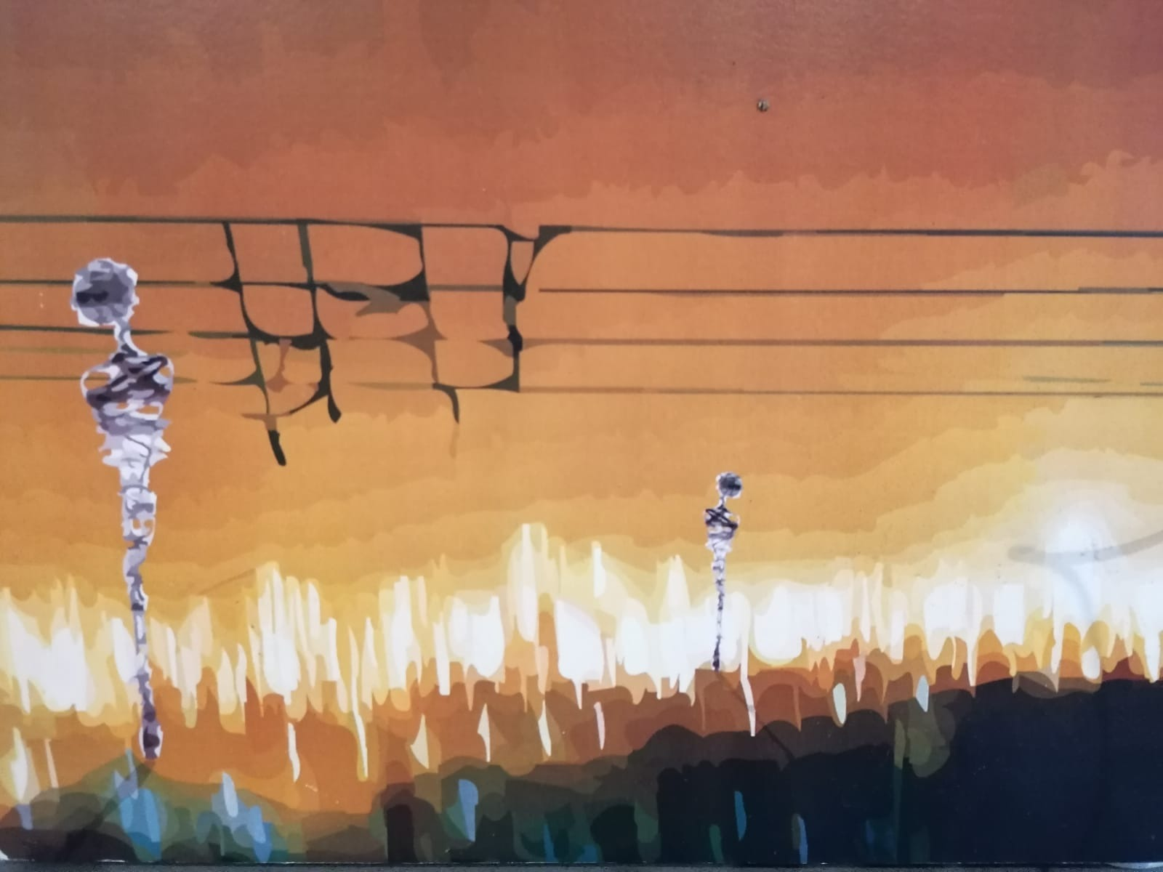
Installation by Rike Sitas and Dean Henning
How do we, adult educators, scholars, activists, play, engage, inhabit ‘climate justice’ – its theory and practice? What roles can we play to mitigate and adapt to the dramatic, anticipated environmental changes? It’s a vast, complex landscape which requires collective insights, imagination, and action. Solving the climate crisis affects all aspects of society. Therefore, our own education as adult educators, scholars and activists is essential.
Three years ago, PIMA started a series of conversations on Climate Justice and ALE as we believed that adult educators and lifelong learning practitioners have much to contribute to inter- and trans-disciplinary teams and movements to develop climate--just responses to the climate emergency that is unfolding. This Special Edition of the Bulletin builds on the webinar interactions – the themes mirror and extend some of those discussions and debates. It is a partial account of the many issues that arise. The Bulletin has three sections: (1) Concepts and contexts (2) What works, and lessons learnt (3) PIMA Business.
The PIMA team which is designing and facilitating the webinars and co-creating this Bulletin, are (in alphabetical order): Liz Boulton, Jane Burt, Shauna Butterwick, Darlene Clover, Colette February, Dorothy Lucardie, Joy Polanco O’Neil, Astrid von Kotze and Shirley Walters (Convenor). We are hoping that the Special Edition can be used as an aid to discussion within our networks to deepen and expand praxis. We encourage you to use it towards this end.
We start with a poem. Serap Brown provides a glimpse of the interconnections between COVID-19 and the climate emergency. We all have rich experience of the last 18 months that can serve us well, to respond to both future pandemics and the climate crises. COVID as a zoonotic disease illustrates the close relationship between the virus and accelerated climate change. As environmental thinker and activist Vandana Shiva argues, the emergencies created by the COVID pandemic, planetary extinction, loss of species diversity and global warming are inseparable.
There are many lessons to draw from our global/local experiences of the pandemic for understanding and responding to climate crises. To overcome COVID-19 and the climate emergency global cooperation and solidarity is needed. How well are we doing on that score? So far, not very well. At time of writing 60% of people in high-income countries have received at least one dose of C-19 vaccine, but around 2% have done so in low-income countries. The vested interests of the economic elites continue to dominate political decision-making. A recent study of climate science shows that climate change studies are twice as likely to focus on wealthier countries in Europe and North America as low income countries like those in Africa and the Pacific Islands – there is ‘a giant climate-crisis blind spot’. Given the urgency of the C-19 crisis and that of the climate emergency, transformative political, pedagogical and organisational strategies and structural changes are essential. The articles respond, in part, to these critical matters.
The first section of the Bulletin elaborates `contexts and concepts`. We start with the immediate global context - the Special Edition coincides with the international climate conference in Glasgow, COP-26 in November 2021. In preparation for this conference, the UN-sponsored Intergovernmental Panel on Climate Change (IPCC) recently released its latest comprehensive report on the state of the earth’s climate. https://social-ecology.org/wp/2021/08/ipcc-latest-climate-report/. The UN Secretary General described the report as a “code red for humanity,” and called for decisive action. Greta Thunberg described it as a “wake-up call,” and urged listeners to hold the people in power accountable.
Jim Falk, chair of Greenpeace in Australia, provides a synthetic view of historical time frames, political contestations, the urgency of the current moment, the need for engagement by all communities and the concrete need for real time data which feeds into trans-national structures to help respond effectively to the unfolding catastrophe. Learning across knowledge and geographic boundaries is crucial to human and planetary survival.
What is ‘climate justice’ and how does it link to lifelong learning? This is addressed by Shirley Walters and Jane Burt. Climate justice foregrounds those people who have contributed least to ‘crises’ and are most affected by them both in terms of ensuring that they can adapt as well as to acknowledge that they have much to contribute to life-affirming solutions. This includes the majority of marginalised women and men.
Mela Chiponda explains how the climate crises disproportionately affect indigenous, peasant and working-class women. Ecofeminism is a useful framework for adult educators to use to analyse situations and design curricula to respond to them, as it refuses to disentangle ecological degradation, capitalism and patriarchy.
Continuing on the theme of ‘connecting the dots’, Astrid von Kotze asks, ‘what does a drought have to do with your daily bowel movements?’ This wakes the reader up to see how our everyday consumption patterns are central to the climate crises. She unpicks the meaning of ‘resilience’ and argues that in the context of climate justice it must be ‘transformative resilience’. Adult educators can helpfully focus on the nexus between energy, food and water to drill down to the bedrock of climate crises.
Climate justice, as elaborated in the Climate Justice Charter (SAFSC, 2020) of South Africa, is born out of the lived experience of climate injustice – the needs for water, food, shelter and against pollution. Vishwas Satgar describes the process of developing the Charter and its strategic significance in the struggle for climate justice. He argues that adult educators must help to build transformative change from below which harnesses the human knowledge project which ‘does not reproduce the Euro-American template of how to live’.
The entry points for climate justice learning and education are vast and varied – what we do know is that the complex landscape requires collective insights, imagination, and action. In the second section, What works and lessons learnt, Joy Polanco O’Neil and Shauna Butterwick are in dialogue with one another, drawing on their own and other life stories, as they reflect on learning about and for climate justice. They argue that effective learning for climate justice must be relational across all life forms and be intergenerational.
As life on the planet is in jeopardy, there is an urgent need to re-imagine, revise, re-create an alternative, more just, healthy and sustainable world. The imagination and aesthetics are powerful in helping to do this. Darlene Clover, Victoria Foster and Joy Polanco O’Neil present creative examples of environmental adult education through the arts which occur in a range of settings. Pierre Walter, in turn, describes the arts-based decolonising educative activism of an indigenous community which leads local struggles for climate justice. Astrid von Kotze turns to novels to explore climate change. Fiction allows us to look at the world differently, to open up and imagine alternatives. Each of these articles provides inspiring possibilities in action.
Specific sites for climate justice pedagogy and action provide opportunities for contextually crafted interventions. Judith Marshall focuses on the critical role of the global mining industry with its enormous footprint and contribution to global warming. She argues that adult educators urgently need to understand and disrupt the mining narrative which projects mining as being `the guarantor of modern life as we know it`. She describes examples of critical adult education in action amongst workers in the mining industries across the global north and south.
The fury of fire, floods, and other extreme weather is now being experienced in towns and cities where residents need protection and then support in rebuilding their lives. Elizabeth Lange describes a process underway in her town where they are learning their way into a regenerative future. They are writing a Climate Action Plan partially about mitigation but also about adaptation. A vital thread is climate justice through truth, reconciliation and decolonisation. They are using the radical power of storytelling to offer the seeds to transform ways of living and to acknowledge that climate change is not the problem. It is the consequence of the problem.
Elizabeth Lange speaks for all of us when she says,
“As educators and scholars, there are so many ways we can offer our gifts and expertise, thereby encouraging important shifts toward a life-giving world. In these small ways, we are co-planting the seeds that create the world in which we, our children, and grandchildren yearn to live”.
Adult educators and lifelong learning practitioners have important contributions to make in the deep and far reaching changes that are needed. We have a long history of working creatively and insistently with power, politics and pedagogy to organize and challenge injustices of various kinds. Attaining climate justice will mean adult educators being part of broader processes of changing public consciousness and developing socio-economic-cultural alternatives – education for people of all ages is a crucial part of the deep transformation that is required.
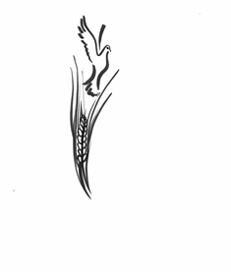
Artist Margie Adam
My Response to CoronaVirus
Serap Brown serap.brown@gmail.com

I did not know
it would be this easy,
to shut down
private companies,
factories
that pollute air and water.
I did not know
it would be this easy,
to see air and water clean,
when humans isolate at home.
And I did not know
it would be this easy,
to take a pause in life,
in countries,
with millions of humans.
Thousands of people,
travelling by planes,
around the globe
now stay still.
Flights are cancelled.
Airports are empty.
Borders are closed.
Are we in war?
I do not know.
Clean air,
Clean water.
No school, no work,
No face to face interaction.
No reason to drive.

No need,
for oil extraction,
finance, production.
Now the focus is on:
Reduction, elimination.
I did not know
it would be this easy,
to witness
global change,
in behavior.
Who would know,
global change in behavior
would spread faster
than a novel virus.
I did not know.
CONTEXTS AND CONCEPTS

Climate Justice and the Knowledge Action Agenda
Jim Falk (jimfalk2@gmail.com)

Hopes are up for COP-26, Glasgow, 31 October – 12 November. This meeting could make a world of difference. There is plenty of evidence that the strength of the IPCC Working Group 1 first volume of Assessment Report 6 (IPCC-AR6), mixed with the now global evidence of climate impacts from global warming, is finally punching through.
Even the Australian Commonwealth government (whose electoral success has frequently been fashioned out of undermining climate mitigation action) is beginning to feel the heat, not so much from climate change as from its international trade and security allies. These are the Australian community and the polls, its business clients in banks, super funds, mining, manufacturing and mineral processing industries, the Business Council of Australia, the Farming Associations, and even, realising it cannot wish the tide back forever, the Murdoch press (although still remaining a platform for their key denier-warrior commentators).
And of course, the climate change sceptics, who have in the past sought to undermine the practicality of alternatives to fossil fuel-based systems, are increasingly being undermined by events and, most notably, realities in the market where solar, wind and battery backup are becoming an economically unbeatable combination.
From a learning perspective, it’s important to recognise how long and arduous the track has been to this point. In 1952 the Paley Commission reported to President Truman that solar energy could play a bigger role in 1975 than nuclear energy. In 1973 the US Atomic Energy Commission reported that solar energy could provide 15-30% of total US energy by the year 2000. These and other reports around that time projected that with modest US government support, the price of solar cells would drop rapidly to the point that the US Defence Department could economically purchase large amounts each year. But of course, none of that happened.
So, are we there yet? Yes, but mostly no. The IPCC AR6 report still shows us on track for 3 degrees of warming; we would already be at 1.5 degrees if it were not for the carbon particulates in the atmosphere and they deplete as we replace fossil fuels with renewables. The Paris Climate Agreement to keep global warming as close as possible to 1.5 degrees centigrade (C) must be compared with actual warming now of 1.1 deg C, warming of about 3deg C or more by 2100, and pledges and targets reducing that to 2.4 deg C assuming they actually are all implemented, which up to now has not been the case. All of this assumes that the feedback we are already beginning to observe, such as unexpectedly rapid melt in the cryosphere and early releases of vast amounts of methane bound up in the warming seas and under the ice sheets, is avoided.
Whilst it makes sense to force through the measures appropriate to mitigating the climate emergency, we need to be mindful that whether it be mitigation, or building resilience to the impacts which cannot be avoided, this response needs to be shared.
Mitigation and adaptation must occur in every community whatever their capacity to implement needed measures. And capacities to respond are deeply unequal across the planet because of inequitable access to finance, technology, and education, including great regional variation in the type, extent and urgency with which impacts are developing.
Yet, as has been shown in the current pandemic, global capacity to share is quite muted. Whilst vaccination rates in the richer countries are shooting up and up (now approaching 80% in some states of Australia) with only 2.7% of people in low-income countries having received at least one dose. Given that COVID mutations are likely to thrive in largely unvaccinated populations, as with climate change, to protect people anywhere, we need to involve people everywhere.
The impacts of climate change are also distributed across populations of strikingly different vulnerability. And their capacity to build resilience to these challenges is also hugely variable, unless global support is given.
So, whilst we hope there will be much improved national pledges as to the voluntary emission reductions, at the forthcoming COP-26, is there something more, consistent with ideas of life-long learning, that might help simultaneously tackle the need for supporting action – whether mitigation or adaptation – across the planet?
To pin that down, it is important to remind ourselves of the odd fragmentation in governance that has characterised human societies – built in recent times around the theory and practice of the ideal of national sovereignty. The edifice of the Framework Convention on Climate Change and the agreements which have evolved over decades under it, reflect that ideal. Nation states report commitments to the global collectivity, but whilst that is helpful, much of the actual action will have to be carried out in the sub-national communities and regions where people live and work. The capacity to support that varies enormously across nation states. The challenge is also to utilise global resources for this purpose.
One approach to this is to work within social movements. Another is a body of work now in its 13th consecutive year of development – Regional Action on Climate Change (RACC) – which has focussed on delivering necessary knowledge resources across borders. It has by now a rather imposing International Advisory Committee composed of very eminent physical and social scientists, which has been guiding the development of a central idea. This proposition is framed within a developed context of not only climate change but its convergence with other global growing risks such as the implosion of biodiversity under the combined impacts of population growth, intensifying economic activity, and the impacts of climate change. The general thrust of this is that relevant actions and policies need to be thought through at global and regional level through an integrated and globally facilitated process.
At its first ever annual Symposium (in 2009) RACC-1 proposed the creation of specialized Knowledge-Action Networks (or KANs) which were to be regionally focussed networks of local decision-makers, researchers and other stakeholders, but supported by international research specialists.
KANs were intended to supply relevant, trustworthy, scientific and technical knowledge useable by local and regional decision makers with the intention of enhancing local resilience for the most vulnerable people in the most vulnerable eco-regions. In short, knowledge action was to be supported, linking networks of people and institutions that provide authoritative knowledge, to networks of people and institutions who influence, create and implement policy.
Whilst KANs have been developed as knowledge hubs in Future Earth, and KAN style consultations have been trialled on a number of occasions stretching from Srinigar in the Himalayas to Egypt, this still has a way to go. It does not have the geographic spread, integration, capacity to integrate complex scientific knowledge and showcase success in eco-innovation required for the successful response to the evolving climate crisis - especially in its full human and planetary context.
It is for this reason that following RACC-13, on 1 October 2021, the International Advisory Committee in conjunction with all speakers at the Symposium has issued a consensus statement “Addressing Our Planetary Crisis”, which calls, inter alia, for global support (in a similar manner to that with which the IPCC has been supported) to bring global information resources in an integrated fashion into a real-time accessible format for local and regional action.
The bottom line is this. The sort of emergency we as humans are creating, is one where we are doing too much to the planetary system, and those trying to respond do not know enough about what to do to fix it. We need a globally supported learning system capable of delivering the best of our evolving knowledge to the multiple places where it is needed, not as is done by the IPCC in seven-year cycles, but in real time. And we need to be able to learn from the success and failure of attempts to respond, in real time. We do not have the system to support that in place yet. But it can be built, and with global agreement to deploy collective resources to that end, that can be done quickly. In the unfolding climate crisis there is no time to hesitate.

"I am no longer accepting the things I cannot change. I am changing the things I cannot accept."
Angela Davis

Climate justice and transformative lifelong learning
Shirley Walters (ferris@iafrica.com) and Jane Burt (jane.realife@gmail.com)
Vandana Shiva (2021) argues that the way we understand the world is the way we relate to it - so if we see ourselves as disconnected from other life forms and do not understand planetary limits, we will violate and destroy Nature for our own ends. If we have deep recognition of our interconnectedness we will act to conserve and preserve Nature. As she says, `oneness and connectedness are the politics of our time`. This requires a clearer focus on the questions ‘which way of knowing and what kind of knowledge is most helpful in a time that cries out for affirmation of life?’ (Salleh 2017, p.283) Key questions for transformative LLL.

Lifelong learning (LLL) orientations and approaches are fundamental to respond to the deep adaptations which climate crises demand. In using the terminology of LLL we include environmental education, education for sustainability and other sub names. Rather than being concerned with the names, we insist on a radical turn away from neo-liberally and anthropocentrically-biased education. LLL, as opposed to some of the other subcategories of education and training, include people of all ages, from birth to death. For example, from birth we need to learn respectful relations to water and the land; to respect diversity of fauna and flora and all living things, as crucial to our collective survival; to value conservation and preservation rather than over consumption.
Artist Margie Adam
But what is climate justice?
The term "climate justice" began to gain traction in the late 1990s following a wide range of activities by social and environmental justice movements that emerged in response to the operations of the fossil fuel industry and, later, to what their members saw as the failed global climate governance model at COP15 in Copenhagen. The term continues to gain momentum in discussions around sustainable development, climate change, mitigation and adaptation. (Holifield et al, 2018)
‘Climate justice’ is a term, and more than that, a movement, that acknowledges inequities and addresses them directly through long term mitigation and adaptation strategies. Accelerated climate change is framed as an ethical and political issue, rather than one that is purely environmental or physical in nature. This is done by relating the causes and effects of climate change to concepts of justice, including environmental justice and social justice. Some argue that it is an alternative to dominant discourses of sustainable development.
Climate justice, as elaborated in the Climate Justice Charter (SAFSC, 2020), is concerned with food sovereignty, health, economic activity, gender equity, housing, transportation, and more. It demands fundamental change in the political and economic order towards socio-economic, gender and racial justice. It is about foregrounding those people who have contributed least to ‘crises’ and are most affected by them both in terms of ensuring that they can adapt as well as acknowledging that they may have the knowledge and practices that the global system needs to embrace.
Brian Tokar (2019) summarizes what a climate justice orientation offers:
- Consistent focus on the disproportionate impacts of climate disruptions on the world’s most vulnerable people who have contributed least;
- Distinct contributions to the climate movement strategies rooted in perspectives of local communities who are on the frontlines. It highlights systemic implications of justice-centred orientations. It links to other kindred justice movements and a synthesis of critical and reconstructive approaches to climate action;
- Several challenging political questions that are raised by this perspective include problems of economic growth in emerging energy transitions and implications of policy proposals in the global north that may tend to sideline justice-centered concerns.
Southern Africa, where we are from, is defined by scientists as a ‘climate change hotspot’. This means that we will experience much more severe impacts with more frequent droughts, less regular rainfall, less certain food supplies, more frequent cyclones and flooding. Average annual temperatures across southern Africa may increase by up to 3 degrees by the 2060s and 5 degrees by 2090s – a temperature that would render human life nearly impossible. (WFP, 2021) To survive we must adapt and change the ways we live, including our ways of farming, restoring our forests, improving our water supplies and management; transition rapidly away from fossil fuels, and, as Ripple et al (2021, n.p.) argue, “develop economies, moving from indefinite GDP growth and overconsumption by the wealthy to ecological economics and a circular economy, in which prices reflect the full environmental costs of goods and services”.
Covid-19 pandemic is also linked to the climate crisis as it’s a zoonotic disease thought to have originated in bats and subsequently transmitted to humans via another animal host. (Armstrong et al, 2020). The Covid-19 pandemic also demonstrates how such crises can exacerbate other vulnerabilities such as increases in unemployment, poverty, starvation and domestic violence. So, what the world has experienced through Covid-19 is a foretaste of what to expect. While we must act urgently to mitigate accelerated climate change, we also must adapt. We anticipate that we have to be in a permanent state of readiness to respond to regular waves of disruption.
Transformative LLL and climate justice
Radical adult educators and lifelong learning practitioners have a long history of working creatively and insistently with power, politics and pedagogy to organize and challenge injustices of various kinds. Working for climate justice is an extension of this long-standing praxis.

Attaining climate justice will mean being part of broader processes of changing public consciousness, recognizing that we have interdependent relationships with our environment, and that we have to use various instruments, political, diplomatic, legal, scientific, financial and educational, towards that end.

The climate crisis is a clarion call to humanity to change how we live. Climate justice requires radical systems change. This radical change is unlikely to be led by those who have both created the catastrophe that is unfolding and are most invested in the status quo, but through people’s action. People, engaging in real-life struggles, learn through action what climate justice means and how it may be achieved. Learning in social movements and through various forms of activism is a vital aspect of transformative lifelong learning for climate justice. (Walters, 2021) In the calls for “civilisational transformation” (Satgar 2018, 2) we have important contributions to make, working together with other scholars, activists, and organizers.

References
Armstrong, F., Capon, A., & McFarlane, R. (2020). Coronavirus is a wake-up call: our war with the environment is leading to pandemics. Conversation, 30 March 2020
https://theconversation.com/coronavirus-is-a-wake-up-call-our-war-with-the-environment-is-leading-to-pandemics-135023
Holifield, R., Chakraborty, J. & Walker, G., (Eds.) (2017). The Routledge handbook of environmental justice. London: Routledge
Salleh, A. (2017). Ecofeminism as politics: Nature, Marx and the postmodern (2nd ed.). Zed Books.
Satgar, V. (Ed.) (2018). The Climate Crisis: South African and global democratic eco-socialist alternatives. Johannesburg: Wits University Press.
Shiva, V. (2021). Divide and rule - the plan of the one percent to make you disposable. Retrieved from https://www.youtube.com/watch?v=f9lq-uBdxg8
Tokar, B. (2019). On the evolution and continuing development of the climate justice movement. 13-25. In T. Jafry (Ed.) (2019) Routledge Handbook of Climate Justice. (pp.13-25). London and NY: Routledge.
Walters, S. (2021). Learning about climate justice in times of drought and Covid-19, International Journal for Lifelong Education. https://www.tandfonline.com/action/showCitFormats?doi=10.1080/02601370.2021.1982038
World Food Programme (WFPP) (2021) Climate change in Southern Africa. A position paper for the WPA in the region. Retrieved from WFP-0000129074.pdf (reliefweb.int)

Ecofeminist popular education
Melania Chiponda
Mela@justassociates.org
Artist Margie Adam
Introduction
The ecological crisis disproportionately affects indigenous, peasant and working-class women who live in disaster-prone areas and whose livelihoods are dependent on the land and the natural environment. As governments, corporations and other institutions largely do not acknowledge the social and economic impacts of climate-induced disasters on women and the world’s poor, women are standing up and raising their voices against climate injustice. Ecofeminist Popular Education approaches are being used to build women’s collective voice, consciousness, and power to confront these injustices. In this article I highlight ecofeminist popular education as an important response to the climate emergency.
Ecofeminism
Ecological breakdown, capitalism and patriarchy are intimately connected to the climate emergency that is unfolding. Ecofeminism, a discourse that began in the late 1980s, remains a useful framework for adult educators because it refuses to separate entangled dimensions of life.
Feminism, colonialism and climate crises
Ecofeminism is an organising and rallying point in the fight against climate injustice. It brings an intersectoral approach to interrogating climate change. It emphasises the significance of gender, class and race, linking feminist concerns with human oppressions within patriarchy and the destruction of nature. Wangari Maathai, a leading African ecofeminist, highlights the close links between African feminism and African ecological struggles, which question both the patriarchal and neo-colonial structures that undermine the continent. The ecological crisis cannot be separated from the growth of capitalism, modernisation and the colonisation project. Present day Africa cannot be understood outside of its colonial history. “New African subjectivities and identities” have been created through Western domination (Bertolt, 2018:3). Shiva (1988) emphasises the importance of understanding Western modernity and civilisation in order to appreciate the climate crisis and the related domination and subjugation of people of the South.
Understanding ecofeminism
Ecofeminism is an activist and political movement that understands that humans are not separate from, or more important than, the natural world around them. We are part of nature. Taking insights from ecology, feminism and socialism, ecofeminism is based on the idea that a system which oppresses people because of their gender, race, class, sexuality and physical ability is the same one which oppresses nature. Due to unequal patriarchal divisions of labour and exploitative practices, the majority of women around the world carry primary responsibility for putting food on the table and taking care of ecosystems, families and communities. Women therefore have a special relationship with nature. Women’s work and care of nature has assisted humankind to sustain itself in every part of the world.
Ecofeminism calls for an end to all forms of oppression, as there can be no liberation of women or other oppressed groups without the liberation of nature. Therefore, women, peasants, and other indigenous groups cannot live decent lives if there is environmental degradation, pollution and other harmful activities. The current environmental crisis is propelled by amongst others, modern ways of producing food and other products, use of fossil fuels for energy, and consumption habits of the rich. The environmental crisis demands deep socio-economic transformation.
Climate change as violence
Accelerated climate change may be viewed as structural violence. Structural violence appears normal and natural because it is violence that exists at a structural level (systemic exclusion, invisibility and poverty), institutional level (surveillance and policing of women’s appearance, mobility and activism), political level (direct threats, attacks and intimidation) and cultural level (ideologies that normalize and legitimize violence).
The impacts of climate change are not distributed equally across geographic regions or amongst the various groups in society. Climate-induced disasters such as floods, droughts, fires, tropical cyclones and typhoons are more frequent and compound the poverty, marginalisation, deprivation, exclusion of the majority of people who have contributed least to the catastrophes and who are least able to respond effectively. This results in deepening structural inequalities, poverty and other forms of injustices that are experienced by women and other vulnerable groups in the aftermath of disasters.
Capitalism and the climate crisis
While there is general acknowledgement amongst mainstream, neoliberal thinking that climate change affects women more severely, it is assumed that access to education and other social services will lessen the impacts of the disasters on women. This is true to some extent but ecofeminists challenge the dominant way of thinking about development under Western male-dominated capitalism. In capitalist markets, goods are produced for profit, and most of the goods produced are not essential for human survival and well-being. Ecofeminists see the growth of capitalism as the main cause of the climate crisis. Capitalism, colonialism, neo-colonialism, and patriarchy are viewed as inextricably linked.
The dominant development model necessitates the expansion of markets for capital to enter and remake itself. Development as the expansion of capital therefore needs to create and sustain poverty and dispossession. This development model is the continuation of colonisation and is part of the project of wealth creation for the few mainly in the North and parts of the South. The current growth-oriented development destroys many women, indigenous groups, and peasant communities. It also destroys nature and, with climate change, is destroying the planet and threatening humanity. For this reason, in many parts of Africa, women, peasants and tribal groups are struggling for liberation from ‘development’ just as they earlier struggled for liberation from colonisation.
Ecofeminist Popular Education
Ecofeminist popular education builds on feminist popular education, the praxis of which has been used over the last 40 or so years. Feminist popular education emphasises the need to challenge patriarchy and capitalism in the interests of women’s liberation. Ecofeminist popular education extends this also to include environmental justice concerns.
Ecofeminist popular education is one of the approaches that is used to build knowledge, critical consciousness and awareness of how women are unjustly affected by climate change, even though they do not contribute much to the crisis. Feminist popular education makes use of methodologies that deliberately create collaborative relationships which are important in building the power of women and raising their voices, in order to act. It is based on the ideas of Paulo Freire, who argues that the road to social transformation is in part through dialogue and “conscientization” wherein marginalized people engage in critical analysis and organize action to challenge unjust and undemocratic economic, social and political systems and practices. When challenging climate injustices and building feminist movements, ecofeminist popular education is integral to political processes with a continual critical analysis of the distribution of power and how this impacts lives of women.
Feminist popular education allows a process of learning that facilitates analysing how Western notions of knowing and solutions to climate change violently undermine local indigenous knowledge systems. The first form of violence against the local systems of knowledge is making them invisible. This invisibility leads to local systems of knowledge collapsing because of the lack of recognition. The second form of violence is to deny the importance of local knowledge by presenting it as ‘primitive’ and ‘unscientific’. This has nothing to do with whether the local knowledge systems are scientific or not, but about power. Western forms of knowledge are also masculine and entail the reduction of humans and nature to ‘scientific’ objects. This is part of the long history in Western economies and culture of nature being treated as something external to humans. to be studied and exploited for human interest and benefit.
Women’s bodies and the bodies of indigenous and colonised peoples have long been objectified and oppressed by Western science. The Western knowledge system came out of dominating and colonising cultures; therefore, the modern knowledge systems are themselves colonising. For all of these reasons, ecofeminists are finding alternative way of recovering and generating knowledge through, for example, ecofeminist popular education and participatory action research.
In Summary, ecofeminist popular education reflects ecofeminist approaches to climate justice. These are:
- Emphasis of connections and interdependency of all forms of life. No life form can exist on its own. Ecofeminism therefore values inclusion, togetherness, relationships, and conserving life. Solutions to climate change must centre these same principles.
- An ecofeminist ethic is based on empathy and care; on the ability to hear and listen. It looks at the body as a source of knowledge, not just biology. Because women live and work in different relationships to land and nature they often have different knowledge from men. Living in relationship to other living beings and nature demands an understanding of and compassion for the other.
- The use of land, water and forests are to be guided by care and an ethic of reciprocity. This is essential to preserve natural ecosystems and their diversity.
- As ecofeminists, we cannot change the systems of oppression by imitating them or playing patriarchal "games".
- Climate justice cannot be achieved under the current oppressive systems of patriarchy, capitalism and new forms of colonialism. Instead, total transformation is needed. This requires that values, beliefs and relations between humans and nature must be rethought.

Through the use of ecofeminist popular education, working together with other scholars, activists, scientists, social movements, reimagining what this means in both theory and practice is occurring within many feminist learning spaces.

References
Bertolt, B. (2018) Thinking Otherwise: Theorizing The Colonial/Modern Gender System in Africa, African Sociological Review 22/1
Farmer, P. (2004). An Anthropology of Structural Violence. Current Anthropology, 45(3), 305-317

Farmer, P. E. (2005) Pathologies of Power: Health, Human Rights and the New War on the Poor, Berkeley, University of California Press.

Ling, C. (2014) The Background and Theoretical Origin of Ecofeminism, Cross Cultural Communication, Vol 10, No. 4 (2014)
Shiva, V. (1988) Staying Alive: Women, Ecology and Development, London: Zed Books

Joining the dots: Transformative resilience for climate justice
Astrid von Kotze (astridvonkotze@gmail.com)
What does a drought have to do with your daily bowel movements? How does poverty relate to a failing municipal grid? How is the resilience of the middle class, based on insurances and investments, a threat to the survival of us all? It seems we are still not able to join the dots between the climate crisis and our business-as-usual everyday consumption patterns.
The day-zero drought in 2018, Cape Town, South Africa, got the 1% used to not flushing the content of the toilet bowl when it was a urine visit, but unlike their working-class neighbours, the 1% did not have to adapt to emptying their bowels into buckets and consider how to dispose of the content, when it was full. Unlike the daily battles of the 99% who spend hours lining up to fill up their containers with drinking water from communal standpipes and who rarely have the privilege of a functioning, clean, private water closet, the privileged classes’ cisterns and taps did not run dry. So, as soon as the rains came, it was back to business as usual for the 1%, resilience no longer necessary, no major adaptation expected. Once the Covid-19 crisis struck, the same 99% were instructed to wash their hands with soap, frequently, but there was no increase in water access and availability, and they had to invent ways of again picking themselves up and sanitising. ‘They are so resilient’, the woman in the shopping mall says with a slight shake of her head, ‘I don’t know how they do it!’ There is some praise behind the wonder in her voice – as resilience has taken on ‘the quality of moral virtue’ with ‘resourceful- ness’ reframed as praise for one’s ability to continually adapt to doing the same (or ideally more) with less, and with one’s performance ultimately gauged in economic terms.’ (Ames and Greer 2021)
In everyday language, ‘resilience’ means the ability to withstand and/or adapt to changing conditions and recover from shocks and stresses. Being bent, but not breaking despite adversity, creating stability despite uncertainty, resilience is the capacity to absorb, adapt, transform and anticipate. In the context of the corona crisis it is primarily seen as the ability to adapt materially, physically, emotionally, mentally to uncertainty and risk. It appears, this can be taught and learned and, indeed, become a business opportunity:

A critical investigation of different meanings and uses of ‘resilience’ must be the basis for using the concept ‘resilience’.
What is resilience?
Both absorptive and restorative resilience aim at getting back to normal, that is, returning to the pre-crisis state. The suggestion that emergency events such as the flooding of New York called ‘a historical weather event’ by mayor Bill de Blasio (NY Times, 2.9.21) are exceptions, ‘freaks’ of nature, is misleading: such events are signals of the climate crisis. (Kelman 2021) Accelerated climate change is a violence created by people, and the continuing encroachment on and exploitation of fragile ecosystems are clear indications of the link between multiple crises and human agency. For poor, rural and indigenous people multiple, frequent, intersecting crises have long been a ‘normality’. They have no choice but to absorb additional dangers as they appear, and to develop a ‘thick skin’ that allows them to continue. They also continuously invented multiple strategies and skills for tackling and averting risks.
Adaptive resilience are the numerous small ways in which we respond to changed circumstances – like using less plastic, recycling, repairing and reusing, establishing home vegetable gardens. Adaptation is an important survival strategy but it does little to change the causes of growing and increasing threats. Furthermore, by not challenging established power elites, adaptive resilience may in fact strengthen those powerful interests. For example, shrugging off extractive energy projects rather than actively supporting alternatives, entrenches dangerous practices and reinforces the injustices to people and Nature. Adapting to increasing news and information blackouts supports authoritarian and populist initiatives that endanger the world.
It is essential to explore the relations of power and dynamics of the capitalist economy that underpin ‘resilience’. An apolitical use of the concept ‘resilience’ neglects the injustices and inequalities that underpin systems. A resilience that aims to be transformative does not advocate a return to the old normal, but considers issues of social vulnerability and differentiated access to power, knowledge and resources. (Ensor et al 2019) People working for transformative resilience argue that systemic failures require systemic solutions. Transformative resilience therefore is a practice of solidarity that goes beyond individuated resourcefulness in the face of precarity, and which emerges from the creation of spaces for participatory and inclusive culture.
Joubert (2019) has warned, ‘Water shortages will wither our food-producing farms or dry up city taps; people fleeing the drying countryside will throng into cities, putting greater pressure on their fragile services; climate shocks like floods, heatwaves and droughts could grind cities to a halt; political instability as food prices rise, water runs out and inequality grows, will ignite existing class tensions’. This is our future, and it is on our doorsteps.
Saving water by not flushing the toilet, using water sparingly when brushing our teeth, are all important adaptations to the water crisis – but they do not fundamentally alter the injustice of the majority of people’s inadequate access to clean drinking water. To become water-resilient implies that every person considers water a precious gift from nature – not a commodity or resource, and sees her/himself as the guardian of water sources and water use. As the Climate Justice Charter (2020) spells out, ‘Nature is endless, and we are just one small part of it. We have to appreciate that every element of an ecosystem has an intrinsic value and must be respected.’
What does this mean for adult education?
Unless we recognise the nexus of water, energy and food, our interconnectedness with each other across race and class, the need to respect and live as part of Nature, join the dots and strengthen solidarity as ‘the earth’s comrade’, injustices such as inequality will threaten all our survival. As the Climate Justice Charter (2020) advocates: ‘Through addressing the climate crisis, which affects everything, we can also advance solutions to all socio-ecological crises and more generally end the war with nature. Systemic alternatives are necessary to address the causes of climate change, its risks and pressures for systems collapse.’
There are a couple of lessons to be learned in order to develop a common transformative resilience. Let’s not go back to pre-Covid skills training and personal development ‘as usual’. As it stands, those who have contributed least to the climate crisis, are hit the worst. Let the ‘resilient’ 99% for whom enough ‘is as good as a feast’ (Neville Alexander) be our teachers in terms of production and consumption. For example, over 500 women’s associations in West African countries, the NSS (Nous Sommes la Solution), have organised themselves into an ecofeminist movement that promotes agroecology and food sovereignty. They promote sustainable farming practices, often rooted in traditional practices held by women. As the leader, Mariama Soko, says: ‘It’s the indigenous knowledge and the practices that have always supported food sovereignty and this knowhow is in the hands of the women … Ecofeminism for me is the respect for all that we have around us.’ (Shryock,2021)
If anticipatory resilience is about looking forward to an-other world, such education would re-introduce local indigenous systems and ways of producing knowledge and in the process generate the opportunity to forge solidarity across all life-forms!
As this example shows, we might start building climate justice education around food, water and energy as issues that directly affect us all and are crucial for poor and working-class people. For this to succeed we must work together: re-organise how we grow, use and build to meet the fundamental needs of all (not the few), and recognise that only common purpose, not competition, can ensure survival. This would be an adult education that affirms life and not just the success of a few who can afford to invest in themselves.
References
Ames, M. & Greer, S. (2021) Renegotiating resilience, redefining resourcefulness, Research in Drama Education: The Journal of Applied Theatre and Performance, 26:1, 1-8. Retrieved from https://www.tandfonline.com/doi/full/10.1080/13569783.2020.1863143
Climate Justice Charter (2020) https://www.safsc.org.za/climate-justice-charter
Ensor, J., Matin, N., Forrester, J. & Davis, M. (2019) What is equitable resilience? Four key elements for putting resilience into practice. Stockholm Environment Institute.
Joubert, L. (2019) Have we already forgotten Cape Town’s crippling day zero drought. Daily Maverick, 2.10.2019
Kelman, I. (21.6.2021) ‘Natural’ disasters are due to societal failures – so, here’s a six-point pandemic recovery plan. https://www.preventionweb.net/news/view/78554
Shryock, R. (2021) ‘Ecofeminism is about respect’: The activist working to revolutionise West African Farming. https://www.theguardian.com/global-development/2021/sep/22/ecofeminism-is-about-respect-the-activist-working-to-revolutionise-west-african-farming

Climate Justice Charter: in South Africa
Vishwas Satgar (copac@icon.co.za)
Synopsis: The Climate Justice Charter is the result of a five-year participatory process across South Africa. The Charter was launched at a People’s Assembly in August 2020. It is available at: https://www.safsc.org.za/climate-justice-charter/,
How is the Climate Justice Charter (CJC) being used to further climate justice praxis?
The CJC is grounded in an emancipatory ecology praxis. It takes human-to-human and human-to-nature relations seriously. This means it serves as a basis to rethink and practise what it means to be a socio-ecological being. Be a human and ultimately a society as part of nature. It holds out a tension in this regard. Are we merely the dominant species with ethical responsibilities to prevent more harm (modest Anthropocentricism) or are we one among many species who share this planet (post Anthropocentricism)?
This tension can only be resolved in practice and through the realisation of a new ethical orientation. Moreover, it provides a critique of the ecologies of capital that are destroying our life world, in particular the climate crisis. The climate contradiction is the most dangerous ecological contradiction we face, with it holding out the horrendous prospect of wiping out human and non-human life. A young person living today will face 7-8 extreme weather events (droughts, floods, hurricanes, heatwaves, storm surges and wildfires) in their life-times. The working class (urban and rural) and grassroots women are going to be further locked into a life and death struggle to ensure socio-ecological reproduction. Water inequality, climate famines, destitution and desperation are going to be worsened. The more carbon capitalism’s ‘lock ins’ prevail, the more greenhouse gas emissions, the more climate shocks reverberate through our life world; the closer we get to extinction.
Thus, the CJC encourages us to escalate this fight to displace capitalism’s ecocidal logic and end the war with nature. It is a rallying call to defend the life-giving commons (water, land/soil, biodiversity, creative human labour and the earth system). Finally, the CJC is a pluri-vision to guide the collective making of a climate justice political project for South Africa and as part of the continent. It is an emancipatory horizon we must reach for now, to shape the depth and tempo of the deep just transition. It is the counterpoint to the shallow ‘green capitalist’ / ‘green neoliberal’ modernising project which places markets, profits and techno-fixes at the centre of the just transition - false solutions that distract us from fundamental transformation. The transformative decarbonisation, systemic adaptation and regeneration envisaged in the CJC are really about democratic systemic reforms that change everything. The policy work, strategies and people’s climate risk plans that derive from the CJC vision deepen transformation and the making of a Democratic Eco-Socialist society now.
How can the participatory process of building the charter inform the process of using it in the future?
There are three issues here:
Firstly, the CJC was born out of the worst drought in the history of the country (circa 2014 till the present in parts of the country). Our South African Food Sovereignty led campaign entailed:
* a hunger tribunal (2015) together with the Human Rights Commission and Faith based communities,
* drought speak-outs in communities and
* a bread march in 2016,
* 2017 the call for food sovereignty pathways in communities, villages and towns to feed themselves and
* the development of a People's Food Sovereignty Act (2018).
Through deep dialogues with drought affected communities, faith-based groups, youth and children, labour, social and environmental justice activists the CJC was developed in draft. Activists were also invited to write think pieces in this process. It was launched as a draft after a conference in November 2019, involving all these constituencies, and placed online for public comment. By August 28th 2020 it was launched by some of the leading eco-feminists in South Africa at a People's Assembly.
Consistent with this bottom-up approach of developing the CJC it is now travelling to all institutions in society - it has been tabled before parliament for deliberation and adoption (October 16, 2020), it has been handed over to WITS University and other tertiary institutions for adoption. It is going to school boards and a bigger push will happen next year to deepen this process as we take it to communities and workplaces for adoption. This process of dialogue and engagement is raising consciousness about climate risks, harms and, most importantly, what we can do to solve this problem together.
Secondly, the CJC is grounding how we engage, enable and construct the deep just transition in our communities and workplaces. It gives us a language, a compass and a coherent approach to what climate justice means. How we establish deep just transition forums, do climate risk assessments in these spaces, the policies we develop, the deep just transition plans we generate etc, will ensure that we meet the needs of the most vulnerable and we transform. While at a macro-level it is guiding the development of a Climate Justice Deal (or Climate Emergency Social Contract).
Thirdly, it is guiding the building of a mass-based movement, grounded in South African experience, conditions and traditions of mass politics but distinctly about building the future in the present. It is enabling transformative politics to give content to systems change, not climate change. Such a movement is and will determine whether we can develop the systems to survive and then meet the needs of the people and ecosystems; ensuring climate justice. From this standpoint, CJC is not about lobbying or finding techno-fixes or using rational scientific argument to solve the climate crisis. Actually, it is about building the next society now, as we live through the onset of catastrophic climate change. If we don’t nurture and develop this new politics, it will have to be invented. Our work on solidarity economy, food sovereignty pathways, defending the water commons, and peoples planning are just some examples of what this means in practice. There is a lot more to do.
How would you like adult educators to engage with the CJC?
The CJC was born out of the lived experience of climate injustice – the needs for water, food, shelter and against pollution. This has enabled a connection to be made between these needs, the climate crisis and the need for climate justice. This connection must continue as a part of adult education, given that climate extremes and shocks are now part of lived experience. Moreover, we are building a new kind of activist who must live the talk, confront their own anti-nature dispositions, prejudices and ultimately, alienation. Adult educators have a responsibility to assist this activist shift to the realisation of the socio-ecological being in all of us. Integral to this journey must be overcoming sexism, racism and class privilege. To be humans in nature is to find a place beyond all oppressive ways of being. Finally, capacity building for transformative change from below is crucial. Collective intellectual knowledge about democratic systemic reforms driving the deep just transition will entail a skilful bringing together of tacit knowledge, earth science, indigenous knowledge and more. A strong appetite to harness the human knowledge project in a way that does not reproduce the Euro-American template of how to live is crucial. Put differently, decolonised human knowledge for innovation, survival and ethical living is crucial.

WHAT WORKS AND LESSONS LEARNT

What Works and Lessons Learned: Adult Learners Engagement with Climate Crisis
Joy Polanco O’Neil and Shauna Butterwick
(joykponeil@thejoyofsustainability.com) (shauna.butterwick@ubc.ca)
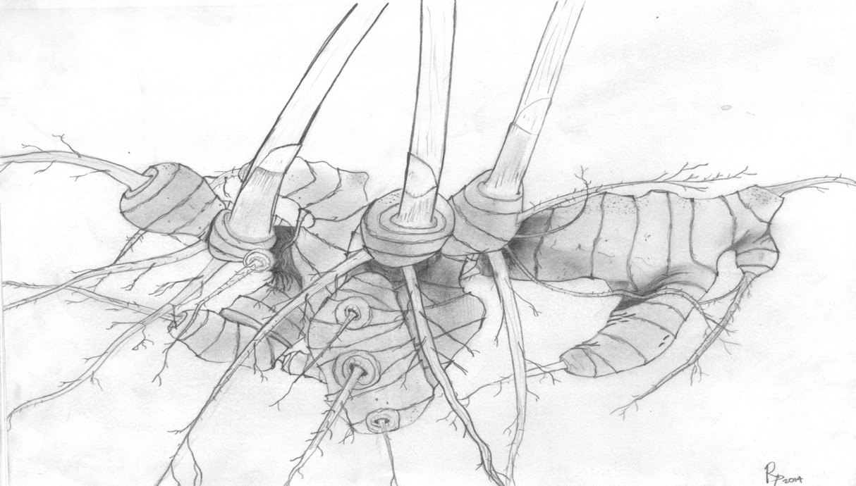
Climate Consciousness
Relational
Teacher College
Grassroots Coalitions
Eateries
Volunteer Clean Ups
Outdoor Activities
Professional Networks
Social Media
Non-Formal Learning
Informal Learning
Formal Learning
Community College
Continuing Education
Bioregional
Research Institute
Social
Certificates
Conceptual
Clubs and Memberships
NGOs
Experiential
Performative
Convivial
Regenerative
Transformative
Organized Events
Community Organizations
Memberships
Farmers Markets
Museums
Affective
Community Gatherings
Figure 1. Rhizome Relationality: Diverse Entry Points for Adult Learning Engagement
Note. Adapted from (be)coming and (re)membering sustainability (p. 51), by J.K. O’Neil, 2015 (UMI No. 3705566) [Doctoral Dissertation]. ProQuest LLC.
Introduction
Working together on this piece exploring what works in adult learning for climate justice has involved a series of online Zoom convivial conversations taking us to many different places. Our approach, relational in nature, was an example of informal learning. The range of topics we’ve touched upon speaks to the breadth of what could be considered the wide and dynamic ‘field’ of learning for climate justice. And it also illustrates how we occupy a kind of liminal space between hope and despair. What has happened in this time together is a realization that entry points for change are much like a rhizome. As depicted in Figure 1, “a map can be constructed and (re)constructed - always detachable, connectible, reversible, modifiable, and has multiple entryways and exits and its own lines of flight” (Deleuze and Guattari, 1987, p. 21). Adult learning is much like these lines of flight. There are many entry points for climate justice education and what we have (re)learned together is how our stories come in and out of all forms of learning. And so,begins our entry point for climate justice.
Our Engagement Dialogue
Joy. I have been teaching for about 20 years in the field of environmental and social sustainability to adult educators in higher education. They are at a time in their lives where life experiences offer a critical understanding of the world around them – often aware of the injustices personally, professionally or in life in general. It becomes a personal journey of transformation, not of doom and gloom, rather of enlightenment and regeneration.
In formal education, I have often seen adult learners complete a course or a program with a powerful energy to be engaged agents of change. Unfortunately, we cannot rely on higher education alone to foster a space or a place for this kind of engagement. My article, Instructional Fragility: Structures of Dominance in American Higher Educational Institutions Inhibiting Sustainable Education, questions four-year higher educational institutions’ unwillingness or inability to enact change needed for sustainability and proposes looking towards “…individuals and organizations outside the institution that may be better equipped to transform or work around structures that impede sustainability” (O’Neil, p. 3, 2021).
So, while students fuel is ignited, I have witnessed students in a state of “now what” feeling of disconnectedness and even, despair. I am not alone in this; former climate scientist Professor Short left her professorship for lack of support for mobilization of change (CBC, 2021). She states, “as education stands now, we are not preparing our students to be successful in their futures, and by admitting to that, we are failing them” (CBC, 2021).
I did not realize this until I resigned from my own professorship. It was evident that students were not ready for my change. I had developed and taught in a sustainability program with climate justice, social equity and transformative education at its core. After I left, graduates continued to reach out to me to stay engaged in change agency efforts and mobilize their knowledge - to be mentored, or guided, to be heard and for support in the “now what” part of change agency work. Their formal education has concluded but as a transformative sustainability educator, I know the environmental and social issues have surfaced, but are not resolved. What is the responsibility of an adult educator once they have fostered a transformative process in a learner? What is the responsibility of the learners? Where do we go and what do we do to stay engaged in climate justice work? And realistically, how can one earn a living wage and sustain engagement?
I do not have the answers and was drawn to further explore adult learner and educator engagement towards climate and other (in)justices related to the environment and society. For my engagement, this meant moving closer to my roots. I moved to California to work in a Hispanic serving community college close to where my mother and grandparents emigrated from Mexico. This meant I was closer to my passion for water and food-related issues where my grandparents served as farm and restaurant workers - almost on the very soil where I now live. They engaged with the land for their livelihood. After hard work, adversity and a few years later, I have an opportunity to engage with the same land, only as an educator.
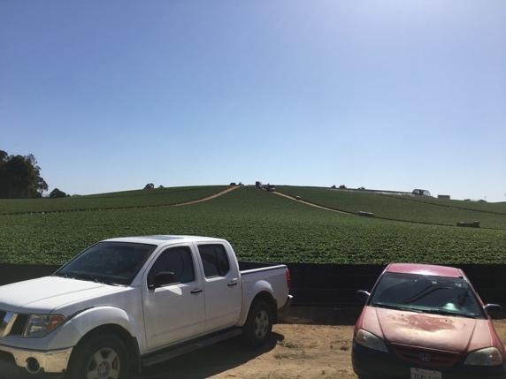
Figure 2. Rooted Relationality: Farm Workers with Soil, Pajaro Valley, CA (O’Neil, J.) used with permission
As Director and Faculty of a Center of Teaching and Learning at the community college, I work with faculty to further their pedagogies and practices in online and in-person learning environments. While this position is not titled, “climate justice warrior”, I have found numerous entry points for change because at this community college level, the tenure track is not so much about “publish, perish and politic” and more into professional development, preparing students to use their hands, minds, and body, to build the workforce on skills and trades, rooted in community – thus community colleges are aptly named. Community college is affordable, and student admission is not burdened with test scores and entrance exams. It’s for everyone. The nature of what community college does is justice work, equity work, environmental work, and community work. It is an entanglement of formal, informal and nonformal engagement.
Shauna. Our conversations, as noted, have covered a lot of issues and experiences and it’s been good to share stories and passions, including the limits and possibilities of higher education as a site of change. Academia has not been my main career. I worked for many years as a community-based health educator and was also active in feminist organizations. While at graduate school studying adult learning, I came to appreciate how adult learning was at the centre of my work and my passions. I felt I’d found a home base. The focus of my thesis and dissertation reflected my feminism and orientation to community-based learning. These foci seem to be recognized when I started teaching at the university After a few years as a part-time lecturer in women’s studies, I secured a tenure track job in adult education. In my research and teaching, I continued to engage with community, however, when I applied for tenure and promotion, the time and effort I’d taken to build partnerships of trust with community was discounted. The size of grants and number of peer reviewed publications were what counted at a research-intensive university. I achieved tenure and promotion and this experience, while heart-breaking, was transformative. It fueled my mission to make community-engaged scholarship recognized and rewarded in formal evaluation procedures. While some changes have occurred, much remains the same.
Over my last 25 years at the university, while I’ve not taught courses focused on environmental education, in women’s studies classes and later in teaching the theories, research and practices of adult education, I encountered many students who wanted the credential but also came to university to acquire skills and knowledge to make the world more just. Much of their learning, like my own, was transformative and at times painful, and so I came to appreciate how transformative learning, indeed all learning, involved risk. Seeing the limits of dominant worldviews, and, at least for me, the biased and privileged life I’ve led, was an awakening filled with excitement but also discomfort and resistance. I was fortunate at the beginning of my MA to take a course with Paulo Freire who was a visiting professor. His ideas, together with my feminist experiences, became key to my academic practice. Freire explores hope as significant in education for liberation. Hope is also central to feminist pedagogy, particularly in the 1970s CR groups where consciousness-raising could only happen when a different and more just world seemed possible. Elin Kelsey wrote Hope Matters – Why Changing the Way We Think is Critical to Solving the Environmental Crisis (2020) and describes herself as a hope activist. Kelsey, like me, feels that we must not fall into despair as we witness the earth in peril. The counter to this is radical hope which is grounded in searching for evidence of what’s working which is unlikely to be reported in the mainstream corporate dominated media. What’s working is the theme in this section of the PIMA bulletin. In my research I found Indigenous art powerfully illustrates our ecological interconnections (e.g., Leah Dorion). Documentaries about Indigenous and land-based practices are particularly illustrative of what can work. The story below speaks to the power of intergenerational and inter-cultural learning for climate justice -- the Water Heart Plan.

The Water Heart Plan
Figure 2. Indigenous Relationality: Water with Trout (Taylor, A.) used with permission
The Tsa Tue Biosphere Reserve
Located in the North West Territories of Canada, Great Bear Lake is one of the last big pristine cold-water lakes, covering 31,000 square kilometers. Here the trout can live for up to 65 years and weigh more than 80 pounds. This amazing body of water is managed by a local Indigenous nation, the Got’ine Sahtu Dené. This pristine lake has been providing food for their families for thousands of years and they want to ensure it continues. This is a popular fishing destination which has led to overfishing and while there has been no forestry activity, a uranium mine has been polluting the waters and destroying surrounding habitat. After decades of negotiation, they took over management of this ecosystem through establishing a land agreement in 1993 and in 2016, they achieved self-government, controlling their environment, education, health and justice. They successfully lobbied the UN to designate Great Bear Lake as a the Tsa Tue Biosphere Reserve, the largest in North America and the first created by an Indigenous community. The Water Heart Plan is their vision based on acknowledging the lake as the boss. Recognizing the lake as a living entity is at the heart of their approach. Declaring personhood status on the environment has occurred elsewhere; it is a significant move towards climate justice. Recently in New Zealand (Aotearoa), a mountain, river and park were granted personhood (Morris & Ruru, 2010).
The Sahtu Dené developed a successful partnership with western scientists in the Department of Fisheries and Oceans Canada who had been monitoring the lake. Indigenous leaders, like Walter Bezha, are central to the collaboration. He brought his experience as a wild life officer who learned the limits of western conservation regulations and wanted to apply a different approach where Indigenous peoples engaged relationally and respectfully with the land where they lived and could hunt and fish, like his grandfather did. In this approach, harvests support only local need and always begin with ceremony where the wildlife are thanked for contributing to the community’s health and self-governance. Sahtu Dené became a staff member at the monitoring station working with Elders who were concerned with unnecessary fish destruction in the Western practice of collecting data by catching and dissecting fish. An Indigenous approach is now used with data gathered mainly through observation and recording. When Indigenous stewards observe fish and wildlife changing or numbers going down, western scientists at the monitoring station bring their approach to assessing the situation. Many Indigenous youth are now staying in the community and work for the Water Heart Plan. One of the barriers to intergenerational learning was language; elders spoke their traditional language, not so the youth. Changes were made to the local school so that all courses are now taught in the traditional language.
This story illustrates how effective learning for climate justice must be relational and intergenerational. It cannot be relegated to the younger generations. Learning with and from Indigenous communities, especially the elders, involves listening and learning from the land, its wildlife, mountains, lakes, prairies, and rivers. Western and Indigenous knowledge and practices can work in partnership with western knowledge when informed by the 4 Rs of respect, responsibility, relevance and reciprocity (Kirkness & Barnhardt, 2001). Great Bear Lake is also a story illustrating epistemological plurality and valuing numerous ways of being and knowing. This story shows us how language is not only a way of communicating, but as a holder of knowledge.

Engagement Practices for Adult Learning for Climate Justice
There is a great turning away from a separation paradigm which informs much Western thinking and practices, towards relationality. Higher education institutions, in our experiences, while privileged places to work and where important teaching for climate justice can occur, are limited. Changing such institutional structures to become more relational is a huge challenge. In Educating During the Great Transformation: Relationality and Transformative Sustainability Education (Lange et al., 2021), the authors draw on Indigenous, whole person, and post-humanist relational ontology. This approach to learning is exemplified by the above story. Lange et al. describe pedagogical stretching as key to turning towards relational approaches; it is “a means of creating relational context and relational learning processes to foster transformative sustainability education” (p. 40). There are no recipes to follow for effective adult learning for climate justice, however, we can learn a great deal about what works by exploring diverse forms and sites of engagement. There are many entry points through formal, informal, and nonformal practices as illustrated in the rhizome in Figure 1. The blue colour represents ideas for spaces for practising engagement and the orange represents the relational epistemology and ontology (O’Neil, 2015) for engagement in these spaces.

Joy. As we bring this conversation to a close, I am reminded that as educators (and learners) we do not need to be one dimensional in our forms of engagement. I encourage my past students to do the same as their responsibility to engage with formal, informal and nonformal learning - much like a rhizome (Figure 1). I used this rhizomatic framework in my doctoral dissertation and have modified it through my engagement with PIMA, my experiences of teaching and learning, my campus and community sustainability efforts, and through writing, and conferences. Although in its early stages, I’ve newly founded, The Dobry Institute, a non-profit organization dedicated to mobilizing a better world through its educational services for socially and ecologically just and sustainable communities. It’s one way I can answer the call to be responsible beyond the walls of academia - to foster relational engagement in this project of transformation.
Shauna. Like Joy, my orientation to community engagement has taught me to appreciate how adult learning occurs within but also well beyond the walls of higher education institutions. Through my academic career, experiential learning and community-engagement informed much of my teaching and research. Through such practices, I can show, not just tell. My own learning about climate justice has been significantly impacted through the PIMA webinars and bulletins. Connecting with this international network of educators, including the amazing work of the WoMin African Alliance (https://womin.africa/) has been transformational. Thank you to my webinar colleagues. Connecting with Joy has been a dialogue across generations. Today, I heard some good news: in British Columbia, the courts turned down the logging industry’s request to continue an injunction against protestors at Fairy Creek on the west side of Vancouver Island, the location of one of the last remaining old growth forests. While the summer heat dome and the fires have abated and the cooler weather and rains have arrived, here in the Global North, I do not and must not forget or ignore the reality of the climate crisis.
References
Freire, P. (2018) Pedagogy of the oppressed. 50th Anniversary Edition. New York: Bloomsbury Academic.

Freire, P. (2014). Pedagogy of hope: Reliving pedagogy of the oppressed. New York: Bloomsbury Academic.

Kelsey, E. (2021). Hope matters: Why changing the way we think is critical to solving the environmental crisis. Vancouver: Greystone.

Kirkness, V. J. & Barnhardt, R. (2001). First Nations and higher education: The four R’s – respect, relevance, reciprocity, responsibility. In R. Hayoe and J. Pan Knowledge Across Cultures: A Contribution to Dialogue Among Civilizations. Hong Kong, eds., Comparative Education Research Centre, The University of Hong Kong. https://www.uaf.edu/ankn/publications/collective-works-of-ray-b/Four-Rs-2nd-Ed.pdf

Lange, E., O’Neil, J.K., Ross, K. (Eds.) (2021). Educating during the Great Transformation: Relational Approaches and Transformative Sustainability, Special Issue for Studies in Adult Education and Learning Adult Education, Sustainable Development, and Environmental Movements

Morris, J. & Ruru, J. (2010). Giving voice to rivers, Australian Indigenous Law Review
49-62.
O’Neil, J. K. (2015). (be)coming and (re)membering sustainability (UMI No. 3705566) [Doctoral Dissertation]. ProQuest LLC.

Short, H., (2021, September 27). Why I resigned from my tenured position teaching climate science in college. CBC. https://www.cbc.ca/news/canada/montreal/first-person-climate-change-education-support-young-people-1.6186611

Environmental adult education through the arts
Darlene E. Clover, Victoria Foster and Joy K. Polanco O’Neil
(clover@uvic.ca) (Fosterv@edgehill.ac.uk) (joykponeil@thejoyofsustainability.com)

What is needed is a new pattern of rapport with the planet…poets and artists can help restore this sense of rapport with the natural world. It is this renewed sense of reciprocity with nature, in all of its complexity and remarkable beauty, that can help provide the psychic and spiritual energies necessary for the work ahead. Berry, 2009, p. 48
Over the past two centuries, human activities mired in myopias of greed and superiority have unleashed a juggernaut of self-perpetuating and self-reinforcing systems of power and exploitation that have placed human societies and other forms of life on this planet in jeopardy (Evans, 2012). Our ecological predicament is what Feminist Rebecca Solnit (2014, n/p) would call “a failure of the imagination” (p. 14), a failure to (re)vision, re(imagine), and re(create) an alternative, more just, healthy, and sustainable world. The imagination and aesthetics are powerful because they enable us “to rethink who we are as human beings…by rearranging us, creating surprising juxtapositions, emotional openings, and startling new presences” (Alder, 2006, p. 490).
Worldwide, feminist arts-based adult educators are drawing on the power of imagination through a variety of arts-based and creative activities. Their aims are to awaken “the ordinarily unseen, unheard and unexpected” (Greene, 1995, p. 28), to evoke emotion rendering visible ecological injustices and to engage people in respectful engaging processes that enable alternative futures to become thinkable, actionable, and thus, possible.
In this article we showcase two diverse types of feminist environmental arts-based education activities. One is a large-scale installation of visual resistance. The other is a gentler process of reconnection to the land in the form of natural sculptures workshops.
People on the Path
People on the Path is a large-scale installation project facilitated by visual artist and adult educator, Hannah Gelderman through the volunteer run group, Climate Justice Edmonton (CJE) in the province of Alberta, Canada. People on the Path consists of several 250 centimetres tall painted portraits of people who call Treaty 6, 7 and 8 (Alberta) home (see Figure 1).

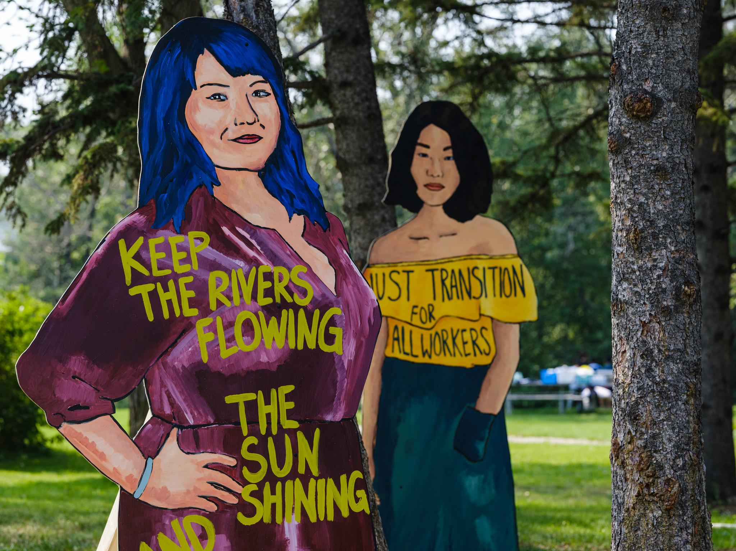

Figure One: Rivers and Transitions

Although there are dedicated people fighting for climate justice in Alberta, the project unfolded in a dominant political and cultural atmosphere of active resistance to climate action as Alberta remains committed to fossil fuel extraction in general and more specifically, to the TransMountain Pipeline expansion project which will pump oil/bitumen to the coast of British Columbia where it would be shipped worldwide on supertankers.
Concerning is the fact that public rhetoric around climate change, Indigenous land rights, jobs and the economy in Albert is habitually and in fact intentionally divisive. People in favour of oil and pipelines are individually and collectively seen and heard; people against are silenced, and often feel isolated. In active protests, when people are highly visible, they are publicly arrested, and criminalised for speaking and acting against the status quo.
People on the Path was designed as a participatory creative process that gave voice to people’s concerns, allowing them to interact respectfully and to design together, forward-looking strategies on climate action that took Indigenous rights, jobs for workers and a just transition seriously. As Matarasso (2019) argues, the process of working together is what helps people of “different skills, imaginations and interests...[to] create something together that they could not have made alone” (p. 49). The time spent working alongside others was for Gelderman and her team, an opportunity to have deep meaningful conversations about what matters and how it can be brought into being. Equally importantly, People on the Path gives high visibility through the large-scale silhouettes to actual people and their concerns, but they are not there to arrest, to humiliate. The art stands in for them (see Figure 2).
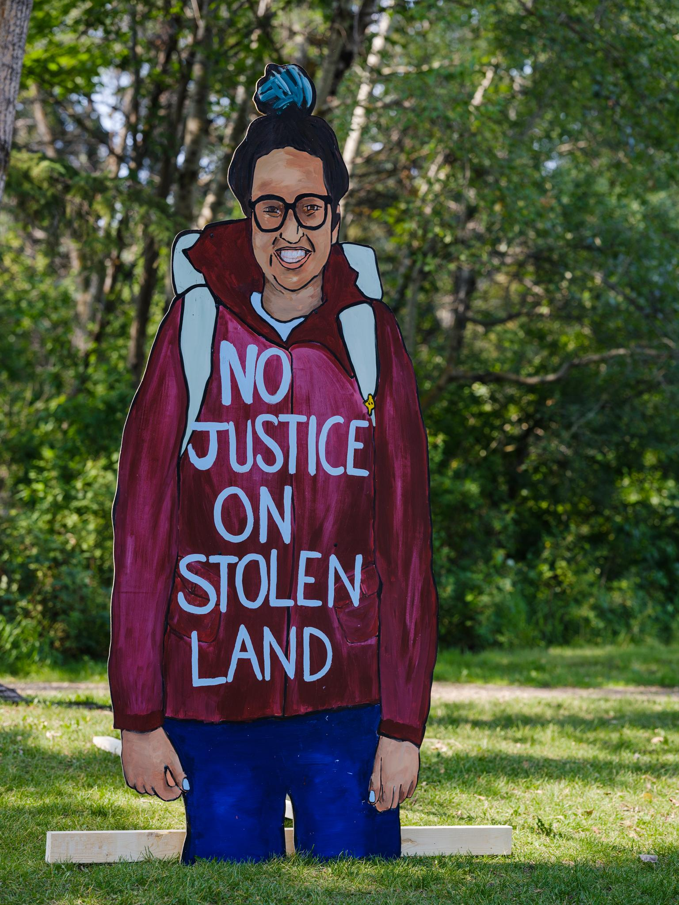

Figure two: Indigenous justice

The project emerged from a collective brainstorming with members of CJE. The decision was to use the arts to give voice, visibility and presence to the absent, to those who oppose the pipeline (and fossil fuel) expansion. It was equally important in the Alberta climate to present a positive vision for the future, one that people could see as viable and hopeful. In other words, the idea was to combine the challenge with the potential, the critique with the hope. To reach as many people as possible, CJE sent out Call for Submissions to groups around the province, asking that people send in a photo of themselves, with a short bio and few sentences on their vision for the future which could be used to create the portraits. CJE then digitally projected the submissions, both the visuals and the stories, onto 122 cm x 240 sheet of plywood. Clothing colours were sometimes changed for aesthetic purposes, such as brightening up or changing a background colour that would increase contrast to the text. Once finished, the portraits were cut out to the shape of the silhouette.
Painting the actual portraits was opened to volunteers and the public and over 50 people contributed (see Figure 3).
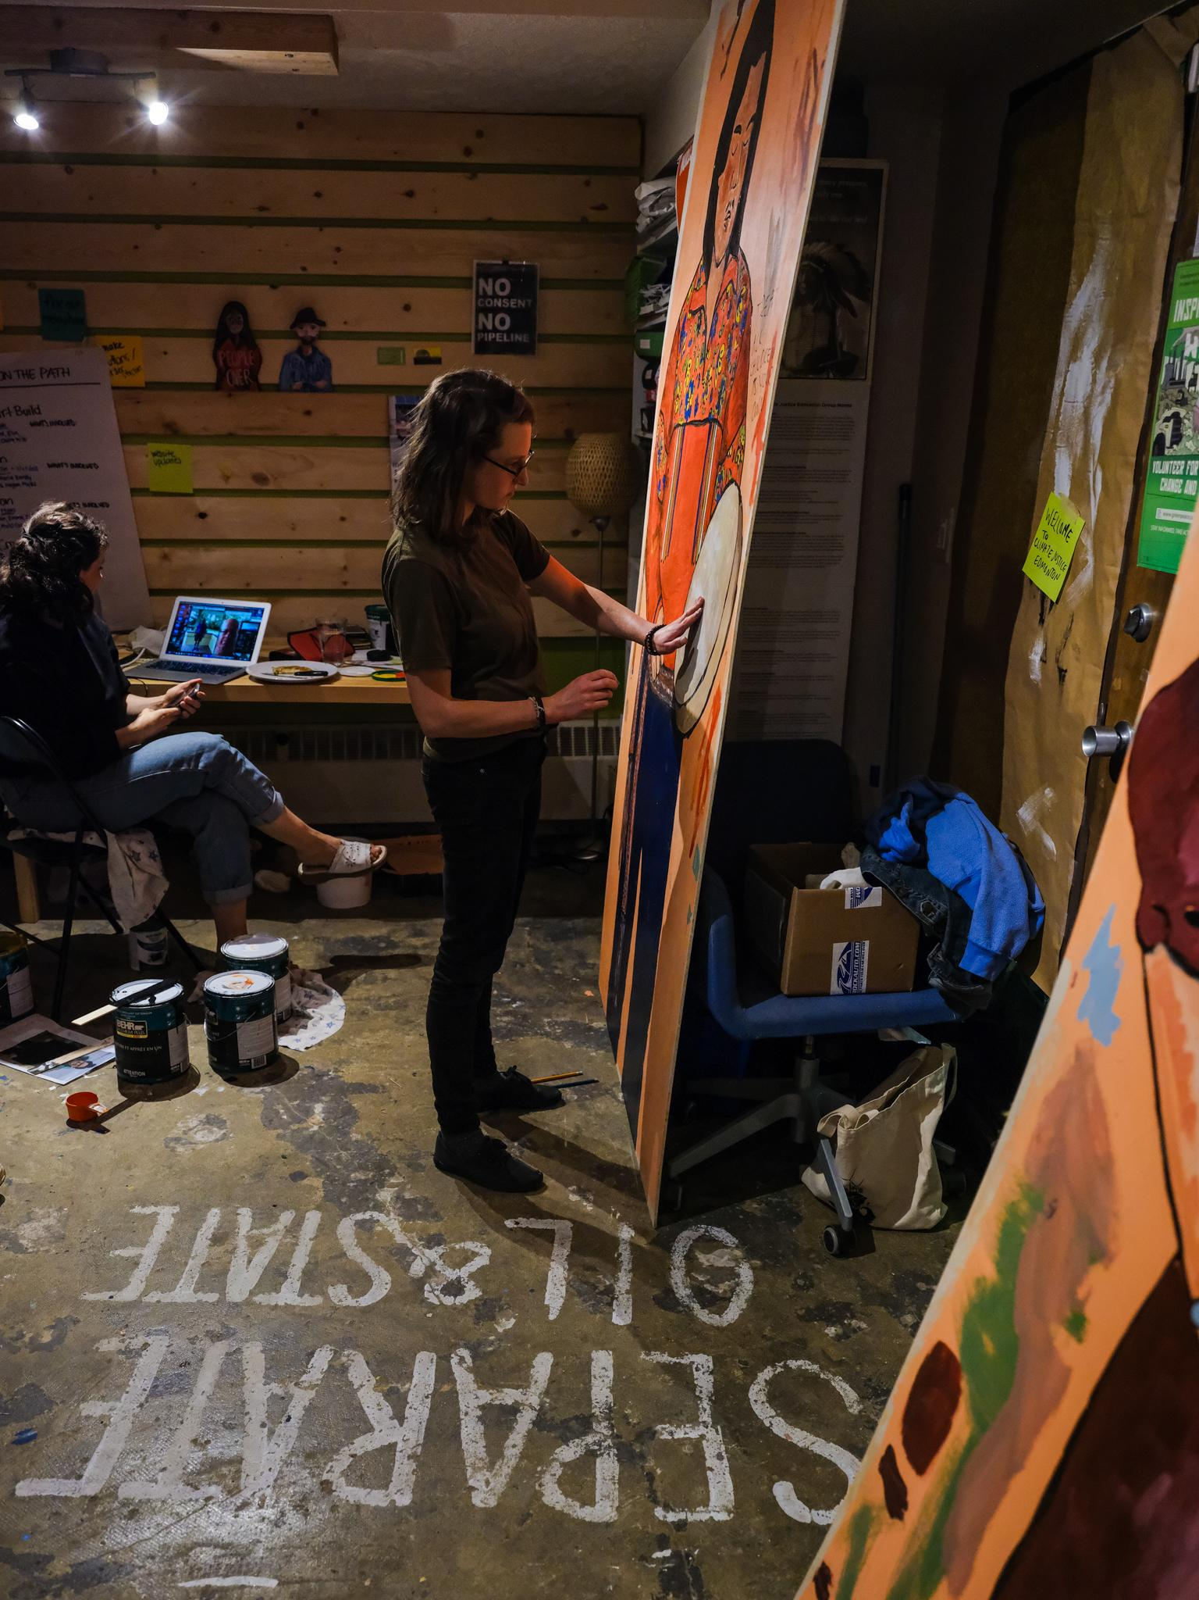

Figure Three: Hannah Gelderman painting

The painting sessions were facilitated as spaces of collective, meaningful dialogue and listening as well as contributing to a highly visible public project. Once 12 portraits were finished, a ‘launch party’ was held in a park in Edmonton, which was open to the public, and included guest speakers on the topic of climate justice as well as food. The project received a great deal of mainstream and social media attention, thereby reaching hundreds more beyond the project, and the response was extremely positive. The portraits have been on display as part of several events and actions hosted or supported by CJE. Overall, the project was a success for the group. Some of the most significant short-term outcomes were increased awareness and strengthened relationships. As a large-scale public initiative People on the Path galvanised new volunteers, and gave CJE and its supporters a visionary means of education and public participation not experienced in any of their previous projects.
Natural Sculpture Workshops
I, Victoria Foster, a feminist adult educator who lives in Northwest England, have over the years, facilitated a variety of Natural Sculpture workshops to stimulate local communities to deepen their relationship with the land. The workshops take place at a community farm, a permaculture project dependent on local volunteers to grow organic fruit, vegetables, and flowers. The Natural Sculpture workshops formed part of a year-long arts-based project at the farm which not only worked with existing volunteers but also brought newcomers to the land to interact with its flora and fauna. The farm, located in the flat lowlands of West Lancashire, is rather haphazardly set out; fruit bushes tangle with groves of unruly willow, and wobbly rows of vegetables contrast with the neatly sown patchwork of fields surrounding it. The Natural Sculpture workshops took place over four weekends in the autumn and were led by two artists from an outdoor theatre company, Walk the Plank, assisted by a group of Performing Arts students from Edge Hill University. The series of workshops culminated in a public sculpture trail event marking the Celtic festival of Samhain, a celebration of the end of the harvest and the beginning of winter. On this cold, clear night, the farm was lit with hundreds of tiny candles and strings of fairy lights; visitors were given lanterns and were guided round the site to see the fruits of the workshops.
There were 20 participants in the workshops. They ranged in age from four to nearly eighty, and all of them immersed themselves in the project and created a joyful range of sculptures and installations. In the first workshop, participants were asked to choose a pumpkin from the freshly harvested, tumbling orange pile in the barn. The pumpkin would guide them to the perfect place on the land for them to work. This exercise enabled an exploration of the land whilst simultaneously engaging people’s imaginations and igniting their intuition. One woman was led by her pumpkin to a willow grove. Willow grows copiously at the community farm, thriving in its marshy land, and it became one of the key materials for constructing the sculptures. This participant busied herself in weaving a huge willow structure which became Hope the Fairy, majestically presiding over the grove (see Figure 4).

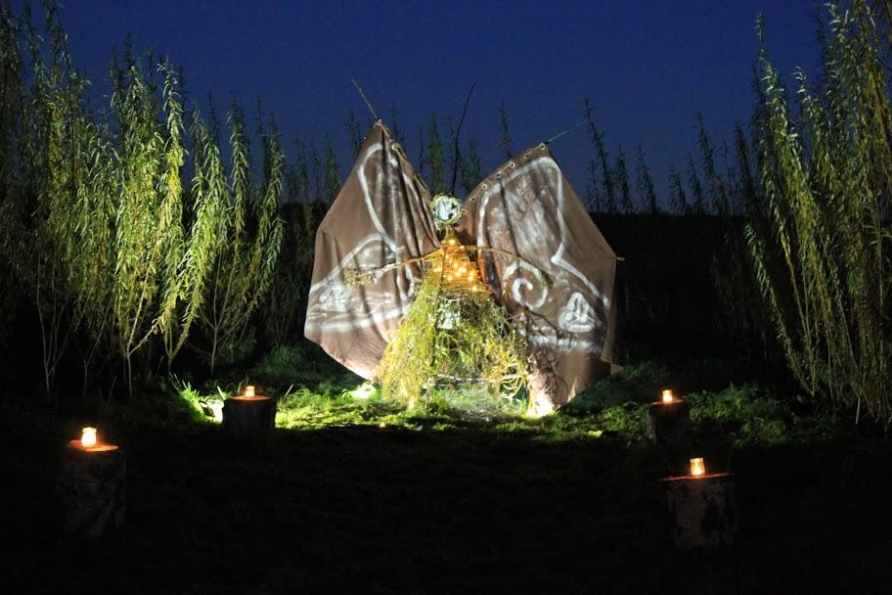
Becka Colley-Foster
Figure 4: Hope the Fairy

In between workshops, she transformed an old pair of brown curtains into a splendid set of wings. A repurposed mirror became the fairy’s face so that, at Samhain, an observer standing at the right angle would see their own face reflected in the mirror and perhaps feel a surge of power and connection with the magic of the land as they momentarily took the form of that goddess-like structure.
An older woman was drawn to a simple sundial that had already been constructed on a patch of scrubby grass at the farm. Inspired by her love of labyrinths, she laboured long and hard to create a spiral path that encircled the sundial. This complete, she turned her attentions to producing an entire solar system of planets made from willow and translucent tissue paper which she surrounded the sundial with (See Figure 5).

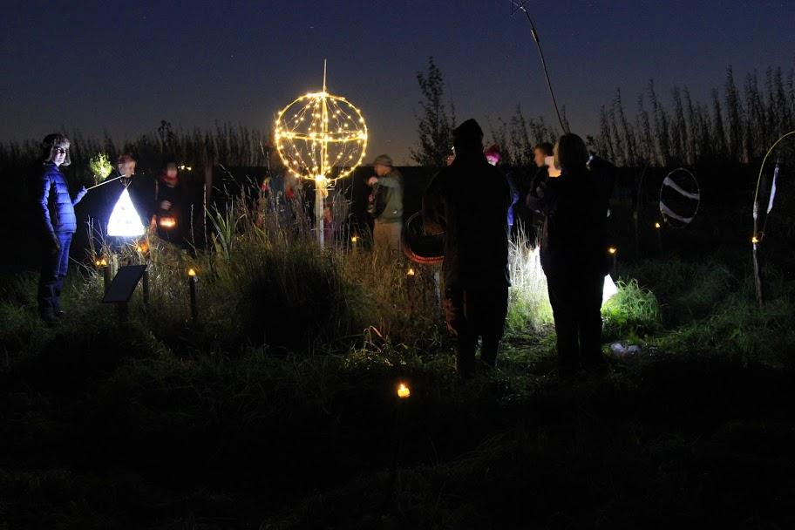
Becka Colley-Foster
Figure 5: The solar system

The work came to life during the sculpture trail. Visitors walked the candlelit spiral path, and when they got to the centre, the creator read a poem she had written about autumn and its leaves; a poem which represented a journey she had taken through grief. Her audience was invited to grab a handful of crunchy leaves from her basket and to throw them at the sundial as a gesture of giving thanks for what had passed, or perhaps making a wish for what was to come.
A third woman made an installation which again, in keeping with Samhaim, focused on the moving from one state to another, from past to future. She built an archway over a roughly mown grass path and hung it with transparent curtains which she decorated with foraged leaves in shades of gold. The participant created a pile of carnivalesque masks which she also decorated with foliage. Visitors were invited to choose one and to wear it as they pushed their way through the curtains, symbolically walking from Autumn to Winter. (Or perhaps it was more than symbolic; the participant insisted that it really did get cooler on the other side.) The path was lined with tiny elemental beings created from natural materials, and large glass bowls were placed in front of the curtain, filled with fruits of the harvest (see Figure 6).

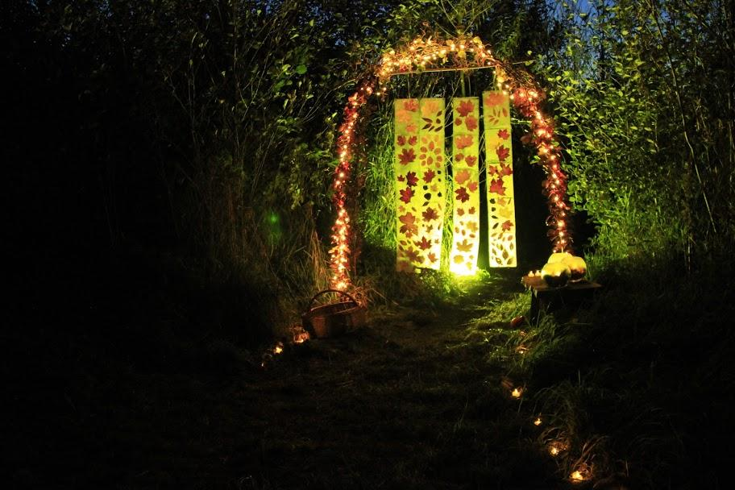
Becka Colley-Foster
Figure 6: Curtains

The Natural Sculpture workshops enabled participants to experience the farm in new and creative ways, and some reported sensing the ‘magic’ that imbued the site. Certainly, the arts can fuel the imagination, make visible the previously unseen and allow us to see things differently (Foster, 2016). They might also help shift our ways of thinking about our relationships with the more-than-human, raising awareness of environmental issues and producing knowledge of and empathy for the wider natural world (Curtis, 2009). This might encourage a rethinking of the notion of community. Abram’s musings, which he shared in an interview with Hine (2011, p. 63) seem apt:
the human hubbub is always nested within a more-than-human crowd of elementals, a community composed first of the particular geological structures and rocks of our locale. The stones and minerals of each place give rise to certain qualities in the soil, and that soil invites a specific array of plants to seed themselves and take root there. Those shrubs and trees, in turn, provoke particular animals to linger and sometimes settle in that terrain, or at least to feast on their leaves and fruits as they migrate through that landscape.
Those animals, plants, and landforms are our real neighbours, the folks with whom we need to be practising real community, if we want to be living well in any place.
After all, the health of the earth and our own bodies are inextricably linked. The outcome is not a matter of having or building relationships rather, being relationships (Spretnak, 2011).
The power of art
Spretnak (1999) claims that we have been living quite problematically, with a mechanistic worldview of modernity which, “…situates humankind in a glass box on top of nature, insisting on a radical discontinuity between humans and the rest of the world” (p. 66). These disconnected, mechanistic systems of thought are causing a range of suffering and fragmented approaches to healing and justice. All this results in a sense of meaninglessness and can go deeper to cause emotional suffering or eco-grief. The ailments of such grief can bring about a sense of climate anxiety, hopelessness, powerlessness, depression, and lack of belonging to one’s own community. As in our cases exemplified here, whether a resistance approach or an approach of relational reconnection to the land, these two diverse types of feminist environmental arts-based education activities offer an emotional, imaginary, and aesthetic rendering of visible and actionable ecological (in)justices. These case studies exemplified offer two approaches to engage people in a creative process that enables alternative futures towards a more ecologically regenerative, just, and sustainable world. They are powerful because they give a presence to absence, make the strange familiar, and encourage creative thinking and acting.
The implications of arts-based adult education are rich for environmental justice and pertinent to adult education whether one’s contexts are personal, intellectual, civic, organizational, social, or environmental. In each of these contexts, art, aesthetics, and creativity are at the core. One of the key ingredients is in how arts-based approaches evoke emotions intertwined with social and material “ignitors” provoked by the arts-based activity. It is to allow ourselves to tap into our imagination resulting in evoking emotions in adult education that frees us to relate and empowers us to enact change. Projects such as these do not stop capitalism in its tracks, they do not eliminate power relations or patriarchy. But what they do is to give people an opportunity to be involved in something meaningful, to come together to imagine and to dream, or to tell their own stories and have a visual voice. And for these reasons, they matter.
Note 1: The stories in this article are adapted from Clover, D.E., Dzulkifli, S., Gelderman, H. & Sanford, K. (Eds.) (2020). Feminist adult educators guide to aesthetic, creative and disruptive practice in museums and communities. https://onlineacademiccommunity.uvic.ca/comarts/feminist-adult-educators-guide/
Note 2: People on the Path photos by Hannah Gelderman; Nature Sculptures photos by Victoria Foster.
References

Adler, N. (2017). The arts and leadership: Now that we can do anything, what will we do? Academy of Management Learning & Education, 5(4), 17-24.

Berry, T. (2009). The sacred universe: Earth, spirituality, and religion in the twenty-first century. Columbia University Press.

Curtis, D. J. (2009). Creating inspiration: The role of the arts in creating empathy for ecological
restoration. Ecological Management & Restoration, 10(3),174-184.

Greene, M. (1995). Releasing the Imagination. Jossey-Bass.

Hine, D. (2011). Coming to our (animal) senses: Dougald Hine talks to David Abram. Dark
Mountain, 2, 61-73.

Matarasso, F. (2019) A Restless Art: How participation won, and why it matters. Calouste Gulbenkian Foundation. Retrieved from https://arestlessart.com/the-book/download-a- digital-copy/

Solnit, R. (24 April 2014). Woolf’s darkness: Embracing the inexplicable. The New Yorker.
https://www.newyorker.com/books/page-turner/woolfs-darkness-embracing-the-inexplicable

Spretnak, C. (1999). The resurgence of the real: Body, nature, and place in a hypermodern world. In P.B. Corcoran and A.E.J. Wals (Eds.), Higher education, sustainability, and the role of systemic learning. Routledge.

Spretnak, C. (2011). Relational Reality. Green Horizon Books.

Indigenous Peoples Lead the Way: Arts-based Decolonising Educative-Activism for the Survival of Mother Earth¹
Pierre Walter (pierre.walter@ubc.ca)

I am writing this as a white settler-colonial man living on the stolen, unceded ancestral and traditional territories of the xʷməθkʷəy̓əm (Musqueam), Sḵwx̱wú7mesh (Squamish) and Sḵl̓ílwḵta (Tsleil-Waututh) First Peoples. Around my city, raging wildfires have burned the mountains east, north and south of me, choking the air with acrid smoke, destroying homes and communities, killing fleeing wildlife. During a recent heat wave, some one billion marine animals in my province were boiled alive by ocean waters reaching 50 degrees Celsius. Salmon, Orca whales, sea stars and bull kelp communities are under threat. Only 5% of our majestic old growth forests of Western Red Cedar, Douglas Fir, Hemlock and Sitka Spruce remain. Our once quiet streets and highways are now clogged by commuter cars, double dump trucks and huge semi-trucks, our once beautiful bay occupied by massive cargo and oil tankers.

Sḵwx̱wú7mesh, xʷməθkʷəy̓əm and Sḵl̓ílwḵta Peoples are leading the local struggle for climate justice, most recently to protect our shared ocean waters from yet another oil pipeline. The 'climate crisis' is nothing new for Indigenous People. They have for 500 years fought off the social, cultural and environmental genocides of racist settler-colonialism, patriarchy, global capitalism, the 'externalities' of toxic, industrial and consumer waste, the killing, starvation and sickening of their people, forests, lands, air, seas and rivers. We have laid waste to immense areas of carbon-sequestering, once green and flourishing Indigenous lands and waters. As in the past, Indigenous and other racialised, poor and marginalized people – people of colour, women and impoverished white people – continue to disproportionately bear the costs of climate change and socio-ecological disaster.

In critical yet hopeful defiance of this climate catastrophe, there are countless Indigenous artists who embrace a vibrant decolonising eco-art-activism. Their educative activism allows us to confront, learn, imagine and take responsibility for our settler-colonial history and our violence in destroying the Earth and its peoples. Somehow – even in the face of settler-colonial genocide, the poisoning of lands and waters by new mining, fracking, tar sands, oil 'spills', pipelines, refineries and tankers; of vast oceans of plastics polluting beaches and seas – these Indigenous artists also manage to retain a resilient and hopeful vision of the future.

Led by Indigenous activists, artists and elders in the Indigenous Rights, climate justice and other social movements, both Indigenous and non-Indigenous people move, in experiencing decolonising arts-activism, from anguish to hope, death to life, destruction to creation, ugliness to beauty, misery to joy. The healing, spiritual, aesthetic and educative power of the arts – music, visual arts, dance, drama – helps us to mobilise hope, to collectively restore our sense of wonder, awe and imagination for better, alternative worlds, and to create these worlds together. Indigenous decolonising art sparks our awareness of Indigenous cultural, ecological and spiritual knowledges and relations with the Earth, of stolen ancestral lands and Indigenous rights to them, of Indigenous resurgence and Earth justice. We learn, see, hear, feel, dance, sing and touch this knowledge in a vast and diverse body of Indigenous traditional/ modern/ post-modern hybrid arts today: Indigenous Hip Hop, Rap, Soul, R&B and Pop music; with traditional, modern and experimental singers, drummers and dancers; written poetry and spoken word; visual, dramatic and oral storytelling; creative and documentary films; multimedia artworks, paintings, graphic art, puppetry, sculpture, all helping to educate us and catalyse socio-environmental change.

Countless examples of Indigenous, decolonizing arts-based educative-activism for Indigenous and Earth justice are flourishing today. Dancing Earth, a grassroots theatre company of 28 First Nations based in Ogaa Po'ogeh and occupied Ohlone territories serves Indigenous and other marginalised communities, 'creating eco-dance productions under the guidance of elders who advise appropriate themes for widespread sharing - including diversity as well as sacred land and water - for the health and wellness of all people and the planet' (https://dancingearth. org). In the summer of 2021, the Lummi Nation's House of Tears Carvers again hauled a 22-foot totem pole across 22,000 miles of road from the Pacific Northwest to the colonial capital of Washington, D.C. 'to bring attention to proposed fossil fuel terminals, oil trains, coal trains, and oil pipelines, and the threat they pose to tribes and local communities' and 'to bear witness to the need for all peoples to work together in the name of our common humanity and our covenant with Mother Earth' (https://redroadtodc.org).

Anishinaabe visual artist Rebecca Belmore has likewise created and performed numerous provocative eco-artworks in public spaces, wilderness areas, museums and protests, on Indigenous lands, together with Indigenous communities and people acting as artist-activist co-creators (www.rebecca belmore.com). Belmore's Ayumee-aawach Oomama-mowan: Speaking to Their Mother, for example, is a giant wooden travelling megaphone inspired by Kanien'kéhaka (Mohawk) resistance to the development of luxury condominiums and a golf course on ancestral burial grounds in 1990. Performances involve a parade to a given site, collective assembling of the megaphone, and an invitation to speak through it directly to Mother. This act of speaking is 'entangled with state power, commercial development, and mass media, as well as First Nations land claims, environmental knowledge, and oral traditions... [Mother Earth is] ... grasped as a dynamic set of relations shaped by participants willing to both talk and listen'; Speaking to Their Mother is an educative act of one of many Indigenous artists against the Anthropocene (Horton, 2017, p. 58).

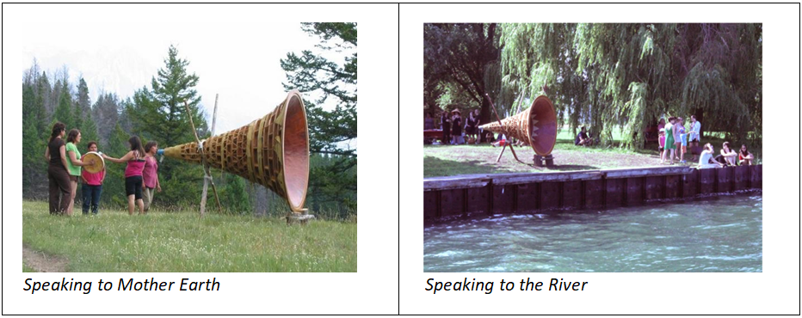
Public Installations of Rebecca Belmont's Ayumee-aawach Oomama-mowan:
Speaking to Their Mother
Sources:
https://twitter.com/womensart1/status/713285995114921988?lang=en (left) https://artmuseum.utoronto.ca/program/ayum-ee-aawach-oomama-mowan-speaking-mother-gathering/ (right)

A last example of Indigenous decolonizing eco-art is the annual 4-5 day Wild Salmon Caravan travelling 400 km up the Sto:lo River through Stó:lō, St'at'imc, Nlaka'pamux and Secwe̓pemc territories along the route of migrating salmon (https://wildsalmoncaravan.com). The Caravan focuses attention on threats to wild salmon, conservation, food sovereignty, climate change, Indigenous knowledges, land and water rights, survival and resurgence. Participants create salmon art, make salmon costumes, sing, dance and parade together, join local protests, and 'experience' what it means to be a wild salmon. Indigenous elders help call the salmon upriver, teach participants about environmental, land-based and cultural knowledge, and offer prayers, dances, songs, food and rituals honouring ancestors, Mother Earth, the river and the salmon. First Nations communities and others along the route host welcoming feasts, local parades, educational festivals and camping sites for participants.

Caravan participants learn about salmon, create salmon art, dress like salmon, sing about salmon, dance like salmon, honour salmon as their relations, begin to feel like salmon, to understand salmon and 'become' salmon as they migrate together upriver. This embodied art-based experience promotes a deep awareness of and connection to salmon and Mother Earth. A threat to salmon becomes a threat to humans. Inhabiting a salmon becomes conscientization towards ecocentrism, deep ecology, and perhaps towards a first, slight outsider understanding of Indigenous epistemologies, struggles, beliefs and worldviews. Collectively making and performing salmon creates a shared identify and purpose in the Caravan ('we are all salmon; we need to do something before we are all killed'). That is, this activist art is a cultural code which sparks learning in unpredictable, organic, bodily and relational ways and results in collective conscientisation, educative-activism and hope for change (Clover, 2002; Walter, 2012), as do the other examples of Indigenous decolonizing eco-art described above.

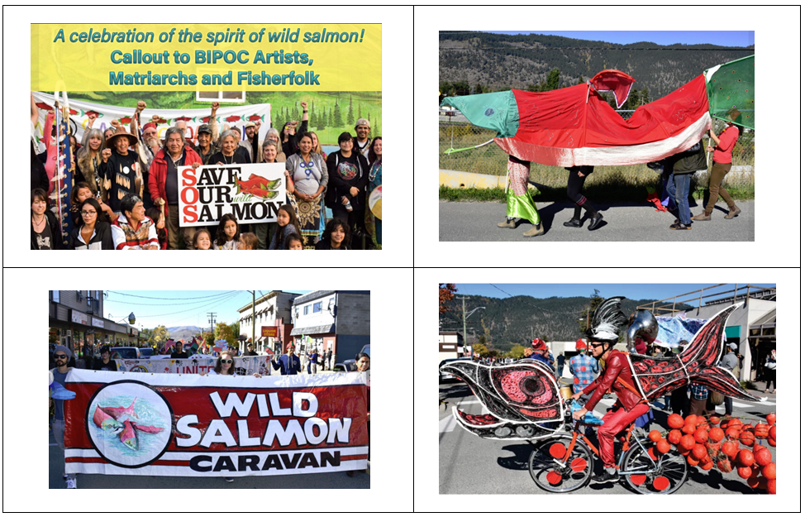
Inhabiting Salmon Art in the Wild Salmon Caravan
Source: www.facebook.com/wildsalmoncaravan

Note: 1. Based on a chapter draft for: Evans. K., Lee, W-O, Markowitsch, J. & Zukas M. (Eds.) (forthcoming, 2023). Third International Handbook of Lifelong Learning. New York, NY: Springer.
References
Clover, D. E. (2002). Traversing the gap: Conscientizacion, educative-activism in environmental education. Environmental Education Research, 8(3), 315-323.
Horton, J. L. (2017). Indigenous artists against the Anthropocene. Art Journal, 76(2), 48-69.
Walter, P. (2012). Cultural codes as catalysts for collective conscientisation in environmental adult education: Mr. Floatie, tree squatting and Save-our-Surfers. Australian Journal of Adult Learning, 52(1), 114-133.

Learning about climate change from novels
Astrid von Kotze astridvonkotze@gmail.com

‘What is it about climate change that the mention of it should lead to banishment from the preserves of serious fiction? And what does it tell us about culture writ large and its patterns of evasion?’ Thus, wrote Amitav Ghosh, in 2016 (2016:14). He suggested that the climate crisis ‘is also a crisis of culture, and thus of the imagination’ (2016:12). I responded to his question by looking for fiction that deals with the climate crisis, and found primarily science fiction novels. I wonder whether setting the problem into a ‘remote’ rather than recognizable context, with imaginary rather than flesh-and-blood characters, might strip it of the dangerous immediacy of the climate crisis and situate proposed responses in fictional reality?
In my search, I remembered Ruth Ozeki My Year of Meat – a book that had affirmed me sticking to a vegetarian diet, and her later ‘All over Creation’ in which the ‘revolutionary’ activists save and swop heirloom seeds and wage war against capitalist monocultures and the destruction of environments. Environmental ecological concerns – but not yet direct engagement with climate change. Barbara Kingsolver’s ‘Flight Behavior’ (2012) taught me about butterflies, and here, for the first time, I was made to consider the much wider implications of atmospheric warming on non-human life. Pollution and climate change have forced the Monarch butterflies off course from their normal wintering site in Mexico, and given the rains and snow, it is unlikely that they will survive. Parallels between human and other sentient life forms are abundant – and they alert me to think more inclusively.
Similar to the monarchs, the river dolphins in Ghosh’s Gun Island (2019) are threatened. Rani and her pod have abandoned their old hunting grounds where chemicals have poisoned the rivers. Although perfectly adapted to their environment the places they have known best could no longer sustain them: ‘Rani must have felt that everything she knew, everything she was familiar with – the water, the currents, the earth itself – was rising up against her.’ (2019:97) Similarly, the people who had inhabited the Sundarbans were leaving…. Having challenged writers to engage directly with climate crisis issues, Ghosh wrote his novel to express the urgency of the matter. After witnessing a raging wildfire, he commented "To see things that you've seen in your mind sort of playing out in real life — it's just so disturbing you know?" "But that is the world that we are in. The world of fact is outrunning the world of fiction." But does fiction have the language to paint this complex reality?
The storyteller in Jenny Offills Weather (2020) ponders how to prepare for what looks like the end of the world. Describing various people who are in a state of panic, she asks: What skills do we need? And ‘What would it mean to bioengineer humans to be more efficient?’ (2020:167)
She finds that an author has inscribed his new book for her: ‘may you be amongst the survivors’ and responds, ‘It’s cold turkey, this thing sometimes. I’m sweating it out. Music helps a bit’. (2020:185)
At the core of the climate crisis lies the distribution of power in the world. If we want to address the crisis, therefore, we need to address the issue of power, and, living in the South where colonialism wreaked havoc in the past and continues unabated, this is particularly crucial. Stripping a people of their ancient knowledges is one way of exercising power over them – and not surprisingly, one way of re-empowering marginal people is by recognising their stories and wisdoms. Gun Island is a modern retelling of a Bengali myth that Ghosh grew up with. The goddess at the centre of this myth is also a sort of interpreter, connecting humans to the natural world. So many of the old legends, tales, stories and even proverbs that are being forgotten by the new generations deal with catastrophes occurring in nature, and we have a lot to learn from those stories and how people have always found ways of living with them – if only we listen!
At the end of ‘Where the crawdads sing’ (Delia Owens, 2018), we find out that Kya, who ‘kept her secrets deep’ had been the often-cited local poet published in regional magazines. Finally, also, the murder is solved leaving me as the reader with a deep sense of satisfaction. Sometimes novels allow the writer to create an end that is more than reality. If only we could simply tip all those who are violently destructive over the edge…. But would that really get us out of the crisis?
Fiction lets us look at the world in a different way. It can open a glimpse of what could and should be – a possibility beyond what is, and it frees our imagination to conjure possible pathways to that alternative. While this novel does not deal directly with climate change it makes some suggestions as to how a respectful relationship between people and nature would fundamentally alter relations of power and processes of production and consumption. Kyla is socialized by the flora and fauna around her; she observes relations between birds to acquire insights into reciprocity, mutuality and care and she demonstrates how sufficiency within a local context ensures sustainable life and living. The values embodied in her ways of living and loving are illustrations of how a healthy buen vivir is both possible and desirable. In this way, the novel demonstrates the dignity of a simpler life that requires massive structural and systemic changes that are within reach – given the political will.

Interrupting the mining narrative
Judith Marshall (judithmarshall9@outlook.com)
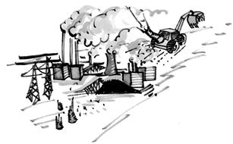
Artist Margie Adam
In her new book, ONENESS vs the 1%, environmental thinker and activist Vandana Shiva argues that the emergencies created by the COVID pandemic, planetary extinction, loss of species diversity and global warming are inseparable. All are rooted in a mechanistic, militaristic and anthropocentric world view that considers humans as separate from - and superior to - other beings. All are rooted in “an economic model based on the illusion of limitless growth and limitless greed”.
Nowhere is the arrogance of this world view more visible than in the global mining industry. With extractive industry projects driving the global economy, never has it been more urgent for adult educators to take on the big oil, mining and gas industries. All of them are skilled educators, shaping how we think about mining through narratives with fulsome promises of jobs, economic growth and development. Until recently they also included grandiose claims to being the guarantors of modern life as we know it. Today, doffing their hats to global warming, the mining industry leaves fossil fuels behind and presents itself as the answer to greening the economy with minerals like nickel and mineral sands.
How do we, as adult and popular educators, create educational tools and activities to alert people to the enormity of mining’s footprint and its contribution to global warming? It is a footprint that extends far beyond the site of extraction to encompass roads, rails, pipelines and sea links to global commodity markets. With a global mining model that puts shareholder profits above mine safety, there are also increasingly frequent mining disasters, with collapses of tailings ponds storing mine waste like the ones at Mt. Polley, Canada (2014) and in Brazil in Mariana (2015) and Brumadinho (2019). These tailings pond breaches create toxic tsunamis that spill into surrounding river systems, many of them hundreds of kilometers from the actual mine site.
Mining story 1: “Free Trade” or “Corporate Privilege”
Education about mining needs to involve both workers and communities. During the 1990s, I was contracted by the Steelworkers Humanity Fund, one of the new labour international development funds established by trade unions in Canada. I was asked to design a course on international development. The course was to be incorporated into the union’s regular labour education seminars on topics like bargaining, pensions and health and safety.
At a Humanity Fund board meeting in 1992, one of the board members made an unexpected intervention. He was president of a local union in a copper smelter. He warned the board that continued member support for the Fund depended on the Fund’s ability to deal with international issues as the workers themselves experienced them. For his members in the mine-rich province of British Columbia (BC), that meant helping workers understand why so many Canadian mining companies were packing up their exploration equipment in BC and heading off to invest in Latin America. The key issues for his members were globalization, free trade agreements and Chile. So, we invented a course called “Thinking North South” which we repeated many times. Lamentably, as Canadian workers felt the impact of the deepening neoliberal agenda over the next 20 years, this course remained as the only point in the union education programme where workers explored the issues of corporate-led globalization, the power and impunity of transnational corporations, free trade agreements, and global rich-poor disparities!
My favourite learning tool was the role play we invented. Moment one was introduced by a news brief on “Eye Witness News”, acted out by the facilitators using a cardboard box TV screen. The news brief informed viewers of yet another BC mining company moving to Chile. The CEO was interviewed on air. He gave fulsome praise to the BC workers and community for their support over the years but said the business opportunity in Chile was irresistible. The newsroom host promised a return to these themes during a conference on Mining and Globalization, to be held the next week in Vancouver.
Moment two was prep for the Conference with workshop participants taking on delegate roles. These included the mining company CEO, government officials from BC and Chile as well as union reps and environmentalists from the two countries. If I were doing it today, for sure Indigenous community reps from Chile and Canada would also be included. For Indigenous voices in Canada, maybe even Indigenous communities in Canada prepared to collaborate with the mining company in return for promises of jobs and revenue and other Indigenous reps saying no to mining, defending the land and its traditional usages. And for sure the voices of women land defenders would be woven in. The delegates were given prep sheets suggesting possible arguments for each delegate’s presentation and possible alliances.
Moment three was the mining conference, with each delegate getting a chance to speak for five minutes and take questions. Alliances could be made during coffee breaks. It was all so close to real life that few of the participants needed to use the prep sheets. They got it readily because they were living it. There was no need for a prep sheet to explain why a mining company would be attracted to copper-rich Chile where skilled workers were available at much lower wages. The mining company CEO was able to draw the government representatives into debates about which jurisdiction would offer the lightest regulatory load and the greatest “flexibility.” The resounding lesson each time we did the role play was the arbitrary power of the mining company to roam the earth at will.
Mining story 2: The Land is Our Life
My work for the Steelworkers continued and came to include coordination of projects in Southern Africa, a region I knew well after working for 8 years in adult literacy in Mozambique. In 2006, Brazilian mining giant Vale bought four nickel operations in Canada whose workers were affiliated with the Steelworkers union. That year, Vale also presented a feasibility study to the Mozambique government for investment in Mozambique’s rich coal deposits. We already had a training project with the union representing miners in Mozambique. Their request to work with them to develop health and safety training for miners was readily accepted, given Vale’s new investments in both countries.
During a visit to Moatize in 2014, with the coal mining operations well underway, I was invited to join a protest march. The protesters were from Bagamoyo, a community situated just outside the outer edge of Vale’s concession. Their homes had not been affected by construction of the mine so Bagamoyans were not entitled to resettlement. Now, however, the mining company had embarked on fencing off the entire concession including large areas not affected by actual mining operations. Vale claimed liability concerns related to possible road accidents.
From Bagamoyo village, land looked like uninhabited bush. As we joined in making signs, we chatted with the villagers and learned that this was by no means “terra nullius.” Generations of Bagamoyan villagers had farms on this land. The maize, cassava and vegetables they grew fed their families and could be traded at local markets. They had fruit trees on this land – mangoes and avocados. Their ancestors were buried on this land. The land supplied medicinal herbs. Their firewood came from this land, as well as branches and thatch for housing construction and animal pens. The river running through the land was not only their water source for drinking, cooking and bathing. The river bank had special clays. Many villagers had built kilns on the river bank for firing artisanal building blocks which they then sold. Far from being uninhabited this land was their life and their commons. Sadly, Bagamoyo is just one of a multitude of traditional communities all around the world which historically have lived off and cared for the land and are today being dispossessed by mining projects.
Extractive projects have huge footprints. The Moatize mine was no exception. The mining operation itself included access roads, giant open pits, crushers, washers, smelters and mine waste storage facilities. Add to that the impact on communities along the road and rail links to ports in Beira and Nacala for sea transport to global commodity markets. Then add the mine’s impact on air, water, soils, flora and fauna all around the mining and infrastructure operations. All of this resulted in massive environmental dispossession After being ravaged by a mining company, the land itself is left defenceless against global warming.
Civil society stepping up
When we face the reality that our governments have succumbed to regulatory capture by private mining corporations, what do we do as members of civil society? Where do we turn when we recognize that our governments are not prepared to defend workers, communities or the environment? How do we identify the spaces where critical discussions about mining are taking place and how do we expand these spaces? These critical discussions may be in universities, museums, churches or in mining advocacy groups. Can they be expanded to local communities?
During a solidarity visit to British Columbia with an educator/activist from a mining community in Brazil, we spent an evening with a chapter of the Council of Canadians in the mining town of Kamloops. Kamloops has long been the home of Highland Valley Copper, which has a gigantic 6-mile-long tailings dam. The local activists were acutely aware of the recent tailings dam spill at the Mt. Polley mine, just four hours away. They had been successful a year earlier in their battle to stop construction of a new copper mine owned by Ajax, a company partially owned by the Polish government with a terrible environmental track record in its operations in Europe and Chile. Kamloops citizens, from city council to local health workers to retired miners, had presented well documented arguments against the new mine. There was active collaboration with Indigenous leaders in the area who themselves carried out an innovative process of consultation as the basis for saying to BC government they gave no “free, prior, informed consent” to the new mine. Ajax was stopped.
When we met with the group, we knew they were concerned about community safety in relation to tailings dam collapses. We had them work in small groups to answer a few questions. Do you know where the Highland Valley Copper tailings dam is located? How big it is? What toxic chemicals are in it? Where would the dam contents flow if the dam breached? Does Highland Valley Copper have an evacuation plan in the event of a spill? Does the public know of this plan? What if every mining community had organized, citizen activists with a focus on mining, interrupting the mining narrative with difficult questions about toxic chemicals in tailings ponds and flow path in the event of dam collapse?
In a world of regulatory capture, when we cannot depend on governments to protect us from mining companies that habitually put profit before safety, is this part of the basic literacy we need to promote as adult educators? Are there new roles for civil society, from local community activists to universities and advocacy groups in monitoring mining projects and ensuring that the rights of workers, communities, including Indigenous communities and the environment are robustly defended?
Local activism can also be magnified at global events. The United Nations has been a focal point for instruments to curb the power of multinational corporations dating back to the 1950s. None has succeeded but the initiatives continue, with special studies and annual meetings in Geneva of an inter-governmental working group. Civil society also has taken organizational initiatives, the most recent being the creation in 2012 of the Global Campaign to Reclaim Peoples’ Sovereignty, Dismantle Corporate Power and Stop Impunity. More than 200 social movements, networks, organizations and affected communities that are resisting mining locally have affiliated with this campaign. With each negotiating session of the official inter-governmental UN working group in Geneva, a ‘peoples’ event has been held outside the Palace of Nations. This event interrupts the mining narrative with street theatre, banners and symbolic acts. There are also regional events to challenge mining like the Permanent People’s Tribunal on transnational corporations (TNCs) which has a very active Southern Africa Campaign that has held hearings in Manzini and Johannesburg.
Each year Canada hosts a major global event for the glitterati of the mining world, the Prospectors and Developers Association Conference (PDAC). Hundreds of government and corporate leaders fill a massive convention centre in downtown Toronto, with displays and seminars to promote mining and special country days designated for mine-rich jurisdictions. And every year, Canadian activists mount an “Interrupt PDAC” event, using a rich mix of popular education strategies. There are “inside” and “outside” interruptions to the mining narrative, ranging from street protests with giant puppets to guerrilla theatre. On PDAC Brazil Day in 2020, the Brazilian community in Toronto prepared almost 300 strips of red cloth, each with the name of one of the 272 people killed after the Brumadinho dam collapse and the 19 people killed at Mariana. Those who joined the street march could choose a name and tie it to a cord stretching between two poles. The multiple red strips flapping in the spring breeze served as vivid reminders of lives wasted by mining companies. My front hallway is still the resting place for these strips, awaiting the next moment when these lives can be present among us, a reminder of why we need to keep up the fight to dismantle the corporate power and end the impunity of the mining industry.

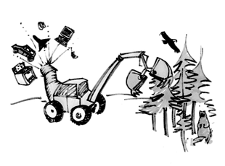
Artist Margie Adam

Climate Challenges: Cities and Towns Getting the Job Done
Elizabeth Lange e24lange@gmail.com
Designing a New Way of Living
We know we collectively need to make significant shifts in carbon emissions by 2030 and develop a profoundly different way of living by 2050. This entails redesigning the way we clothe, house, feed, transport, warm and cool ourselves, as well as how we make collective decisions, heal, educate, work, communicate, and use Earth-based resources.
Yet, each international climate meeting reinforces that those national governments and global corporate leaders cannot rise above their vested interests. They want to know they can either get re-elected or make money from the agreements. It is not about a vision of a survivable, liveable future or the impact on, seven generations from now. We are not unique in short-sightedness though, as many civilizations have fallen by outstripping resources.
Transformation through Cities and Towns
So, how will this transformation come to pass? The most significant changes are being executed by municipal governments and citizens groups around the world. As Schumacher noted in Small is Beautiful, we need human-sized systems. So, it is cities and towns that provide a scale much more workable. Cities and towns can build robust citizen engagement and offer participatory democracy in everything from budgeting to policy-making. Cities can develop the policy and regulatory measures to stimulate innovation and new types of businesses. They have power over land-use planning, water provision, transportation, and building codes. City leaders can scale up the workable innovations.
Further, cities and towns experience the fury of fire, flood, extreme weather, and superstorms, need to protect residents, and then rebuild. Their residents are counting on them to get the job done. While national governments may provide funding, it is not national governments or international agreements getting the job done on the ground.
The Five Zeros
Former Toronto mayor David Miller describes in Solved: How the World’s Great Cities are Fixing the Climate Crisis, how the cities who belong to the C40 Climate Leadership Group have made substantial strides towards reducing their carbon emissions. Originally 18 but now 97 cities, they represent over a half billion people and a quarter of the world’s economy. Their overall goals are the “five zeros”: a zero-emission energy grid, zero-emission buildings, zero-emission transport, zero waste, and zero waste of water.
Frustrated watching Climate Summit negotiations, the mayors gathered at their own summits. The primary problem was that megacities (over 3 million) produce 70% of the world’s emissions and smaller cities contribute less because of their size. They consume two/thirds of the global energy supply, including the 25% from renewable sources. Since 2005, megacities can sign a Global Covenant to become a net-zero carbon city.
Early members agreed to peak their emissions by 2020, halve them by 2030, and achieve carbon neutrality by 2050. By 2020, 34 cities are on target for peaking their emissions. They are retrofitting building infrastructure and all new buildings must be net zero/carbon neutral. Cities such as Vancouver, have set their sights on doubling the number of green jobs and green companies over 2010 numbers. Many cities are moving toward zero waste by reducing the total solid waste going to the landfill or incinerator. Further, these cities are moving toward much more compact, mixed-use development and extensive parkland, making active transportation instead of passive transport in vehicles, a more attractive and a healthy, safe option. They are improving quality of life, including liveability and prosperity.
For example, in 2020, Toronto is now 33% below 1990 levels of greenhouse gas emissions. Oslo developed a carbon budget and is aiming for 50% reduction in emissions by 2022. City staff are simply not allowed to go beyond their carbon budget, which has significant ownership and pride by Oslo residents. Paris is using participatory budgeting and allots at least 20% of its budget to climate issues, including retrofitting 5,000 apartments annually. New York City has a Green Jobs Corps which trains low-income communities in the construction sector, partly to help “build back better” the areas hard hit by extreme weather. Barcelona is ensuring that every resident is only a 10-minute walk away from a climate shelter, given extreme heat waves. They have developed “superblocks” which are completely car-free, enhancing outdoor life, air quality and equality of accessibility. Bike-shares and car-shares have been adopted in many cities as have climate resilience initiatives for “future-proofing”.
The C40 partnership now has significant funding partners, research expertise, measurement inventories, and peer teaching experiences, to develop replicable changes. Climate-positive development in Innovator Cities requires holistic planning, knowledge of best practices, and strong policy, regulatory and procurement frameworks. The stories from Stockholm, Jaipur, London, Sydney, and Rio are exciting.
My Town: Learning our Way into a Regenerative Future
I am inspired by my local town council, District staff, citizen committees, and local activist non-profits who together are generating ideas, research, feedback, and pressure. Our town is dedicated to participatory budgeting and citizen participation on town committees which design new policies and practices, aiming for zero emissions by 2050.
As a member on the local climate change committee, we all come with diverse expertise—from data savvy folks to social service providers to activists and researchers to educators and climate communicators as well as one town councillor. Together, we are researching and applying creativity to find the strategies, policies, and measurement tools for mitigating emissions. We are writing a Climate Action Plan, partially about mitigation but also about adaptation to the climate changes that are already locked in. The third vital thread is climate justice through truth and reconciliation and decolonization. Front and centre is ensuring that households have equal access to affordable solutions and incentives for encouraging shifts, so no one is left behind or bearing the brunt of climate change. The local Indigenous peoples on whose land we live, are way ahead of the town on going solar, installing heat pumps, building net-zero, regenerative fishing, and teaching others.
The Radical Power of Storytelling
In our education and engagement subgroup, we are using a story or narrative approach. We know that fear, shame, and blame approaches have not worked in environmental and sustainability education or climate communication, otherwise we would not be in this situation. As Denise Withers says in Story Design: The Creative Way to Innovate, we all have innate narrative intelligence. From the earliest beginnings of humanity and cave paintings, we humans have been telling stories. As Martin Shaw says in Courting the Wild Twin, stories are “not enchantment”, “not escape”, but about “waking up”. There is radical power in storytelling.
Stories offer the seeds to transform our way of living. Stories have an alive quality, in fostering awareness and a sense of relatedness with the world. We are excited about the story design approach and the clarity of thought it enables. Here is the logic behind our storytelling communication, and eventual public workshops.
Climate change is not the problem. It is the consequence of the problem. The problem is how we live…out of balance with natural systems and thereby degrading our life support system. We know that climate change has become partisan, so we need to bypass the political spectrum in our messaging. Our big purpose is human survivability as well as local liveability. The question that creates tension in this story is: will we make it in time before our societies begin to disassemble?
The resolution in our story is transforming to a different way of living, a regenerative lifeway. The vision we are holding up in our story-making for local citizens is how we can our live together better, regenerate a way of living within the capacities of natural systems, and foster an abundant and inclusive community. Desiring this more than what we have, or especially what is coming, is what will motivate us all to make the changes.
Our data folks assessed that we could reduce our emissions by 7% a year in two ways: 250 people reducing commuting to the nearby city and 250 homeowners shifting to heat pumps. Our initial strategy is asking commuters to either buy an EV, use a car share, electric bike, or transit, or use a new local teleworking centre. We aim to reduce building emissions by enabling home and business owners to shift from fossil fuel energy sources to the use of heat pumps and solar. We are developing a toolkit of multiple rebates, group purchasing, low interest financing, bonuses, free transit passes, and many other concrete incentives. We are illustrating the cost-effectiveness of these shifts and the collective impact, moving people over the decision hump. This is our 2022 focus…with lots to come.
As educators and scholars, there are so many ways we can offer our gifts and expertise, thereby encouraging important shifts toward a life-giving world. In these small ways, we are co-planting the seeds that create the world in which we, our children, and grandchildren yearn to live.

PIMA BUSINESS
Report on webinar
Webinar in PIMA’s Climate Justice and ALE Series, held on 13 October 2021
Shirley Walters ferris@iafrica.com and Astrid von Kotze astridvonkotze@gmail.com
Ecofeminism makes sense: towards life-affirming adult learning and education (ALE)
“A single ecological community is the only solution” – this is the message Jacklyn Cock left participants with, at the end of a vibrant, well attended webinar.
The webinar is part of PIMA’s Climate Justice and ALE webinar series, co-hosted with Adult Learning Australia (ALA), Canadian Association for Studies in Adult Education (CASAE) and Standing Conference on University Teaching and Research in Education of Adults (SCUTREA). There were close to 100 registrants with 50 attending. The two speakers were Jacklyn Cock, Professor Emerita in the Department of Sociology at the University of the Witwatersrand, South Africa, where she is also Research Professor in the Sociology of Work Unit (SWOP); and Serap Brown, a Turkish/Canadian poet, film-maker, adult educator, and PhD student who is using ecofeminism and decolonization in her praxis.
Jacklyn drew on participatory action research on the lived experience of coal-affected communities. She suggests that many black working-class women living in such communities in contemporary South Africa are expressing, in their actions and practices, an eco-feminism that is a form of resistance to social and environmental injustice. While not claiming eco-feminism as an identity, these women are providing a unifying narrative in the form of an African eco-feminism, but at enormous cost to themselves as violence to anti-coal activists, who are predominantly women, is increasing. (Here is a link to a related chapter which makes compelling reading: https://www.swop.org.za/post/our-existence-is-resistance-women-and-the-challenge-of-the-climate-crisis-and-covid-19-pandemic )
Jacklyn presentation covered four aspects: firstly, that eco-feminism can provide us with a new political imaginary. It can be a conceptual tool to cut through the frozen imaginaries of people who cannot envisage an alternative to our world with its savage inequalities and environmental destruction. Secondly, this alternative world requires a different understanding of nature, an understanding that involves the decolonization of the present dominant practices and understanding of nature, and instead emphasizes the interconnectedness of all life forms. Thirdly, that eco-feminism involves practising solidarity, and fourthly that it means massive, systemic change.
She offered an overview of various forms of ecofeminism defined by solidarity with other women, a way of life, a way of practising commitment to collective action for a just transition. Critical of the elitism of liberal feminism, she highlighted the importance of class and a commitment to socialist ecofeminism, in order to replace a society built on profit rather than with the satisfaction of human needs. However, she warned that using ideological labels may lead to undermining solidarity – labels can be used negatively or inspirationally. She reminded us to `live simply so that others can simply live`, and emphasized the importance of ‘mutual sharing and support, instead of the possessive, consumerist, competitive individualism of neo-liberal capitalism’.
Serap Brown’s presentation was entitled ‘In search of a new paradigm: water as my teacher’. She utilized experiences of her quest to build a new relationship with water as part of the shift from a `separation paradigm`, which carries the techno-industrial values of Western Eurocentric culture, towards the ‘relationality paradigm’. She shared a film I am River. https://www.youtube.com/watch?v=HWa5kfgx3dQ, that she has made, and poetry to demonstrate different ways of challenging the binary dualism of the human/nature division.
Serap spoke to some of the many ways of integrating ecofeminist principles into life-affirming adult education: utilising the arts with creativity and authenticity; creating dialogical spaces; storytelling; learning from oral stories of people and the land; conducting outdoor and experiential environmental education programs; collaboratively creating wild pedagogies; opening space to voice and listening, including the voice of nature, amongst others.
With the-juxta positioning of the different contexts of harsh working class, impoverished communities on the coal mines in South Africa, and the relatively empty natural landscapes of Canada, the scene was set for very rich conversations as to how, within different contexts, we address the dualisms of the contemporary period; in particular, how do we develop a new understanding and relationship to Nature? How do we move towards a single ecological community?
This report cannot do justice to the rich, provocative, and stimulating dialogue; therefore, we encourage you to listen to the recording of the webinar at:
https://dl.dropbox.com/s/cdbtx4sk2i9sstc/EcofeminismWebinar.mp4

We end with the first part of a poem:
By Serap Brown
Becoming and Being

I did not become an ecofeminist
I have realized, I just am, because…
I did not become a feminist
I just am. How could I not be?
Witnessed women who
were oppressed
silenced
erased from history
made invisible,
who could not
practise their will,
and become fully human.
I did not have a choice to become a feminist.

And I did not become an environmentalist.
I just am. How could I not be?
Witnessed crystal clear, running waters
Turn grey, heavy, thick and dull.
Witnessed legendary ancient forests,
holding wisdom,
huge giant trees,
eradicated, cleared.
Forests in relations, home to many
birds, wolves, fish, and water.

Witnessed life slowly and painfully
disappearing from the land.
My loved ones have been fading away.
I did not have a choice to become an environmentalist.
I just am. (continued)

Welcome to New Members
Yashvi Sharma
Ms Yashvi Sharma yashvi.sharma@pria.org, yashvisharma90@gmail.com is a Training Specialist in India’s Participatory Research in Asia (PRIA) currently supporting various programmes of PRIA that focus on building youth-leadership to end gender-based violence and sexual harassment at the workplace.
She is a development professional with more than six years of experience in the non-profit sector in India. She specializes in participatory training, capacity-building, community mobilization and programme implementation. She has been evolving various creative learning methodologies to engage adolescents, youth, and women on issues of gender-based violence, sexual health and hygiene, and livelihoods.
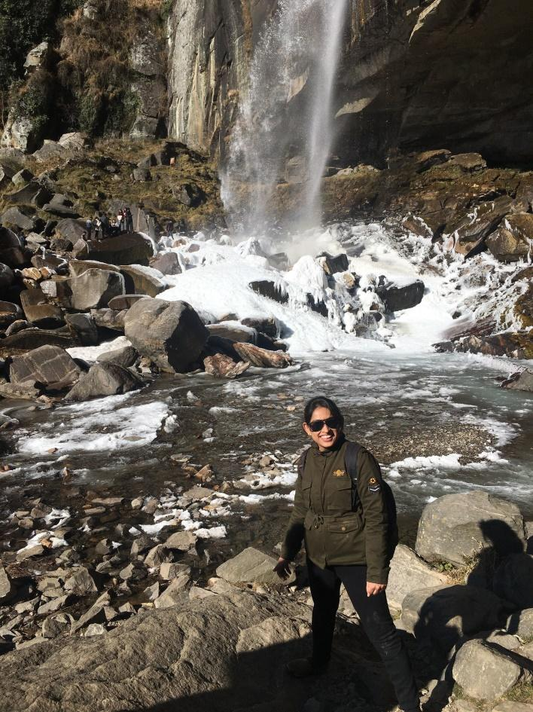

Melania Chiponda chipondamel@gmail.com is an Activist Researcher, Lecturer at the Women’s University in Africa in Zimbabwe, consultant, and the Founder of the Centre for Alternative Development doing voluntary work, also an active ESCR-Net (Economic working group) member. She is a PhD Candidate in Development Studies, holds a Master of Science in Development Studies, a Bachelor of Science (Hon) degree in Sociology and Gender Development Studies, and several post-graduate qualifications.
She is an African Ecofeminist, her environmental justice and climate justice work within the extractive sector stretches over 20 years defending lands, territories, women’s dignity, and human rights. She is a movement builder with expertise in popular education with climate justice and
environmental rights activists and women land defenders across Africa.

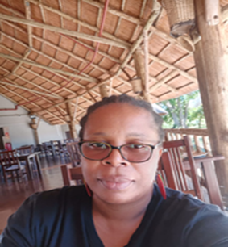

‘Nuclear Power Costs’, Hearings before a Sub-committee of the Committee on Government Operations, House of Representatives Ninety-Fifth Congress, 12-19 September 1977, US Government Printing Office, Washington, 1977, p. 1181.
Ibid p. 50.
Jim Falk, Global Fission: The Battle Over Nuclear Power, Oxford University Press, Melbourne, 1982, p.84.
Our World in Data, https://ourworldindata.org/covid-vaccinations, 18 Oct 2021.
See for example, Shirley Walters (2021), Learning about climate justice in times of drought and Covid-19, International Journal of Lifelong Education, 29 Sep 2021, https://doi.org/10.1080/02601370.2021.1982038, pp. 3-4.
https://www.stsforum.org/racc/iac.php
Falk, J., Colwell, R., El-Beltagy, A. et al. Beyond 2020: converging crises demand integrated responses. Sustain Sci 16, 2021, pp. 691–693. https://doi.org/10.1007/s11625-020-00876-w
Jim Falk, Faten Attig-Bahar , Rita R Colwell , Swadhin Behera , Adel El-Beltagy , Joachim von Braun , Partha Dasgupta , Peter Gleick , Ryuichi Kaneko , Charles Kennel , Phoebe Koundouris , Yuan-Tse Lee , Thomas Lovejoy , Amy Luers , Cherry Murray , Rattan Lal , Ismail Serageldin , Youba Sokona , Kazuhiko Takeuchi , Makoto Taniguchi , Chiho Watanabe , Tetsuzo Yasunari, “Addressing Our Planetary Crisis”, Sustainability Science , 2021, in press.
https://africanarguments.org/2019/03/why-world-needs-african-ecofeminist-future/
https://www.leahdorion.ca/gallery_the_giving_tree.html
http://www.unesco.org/new/en/natural-sciences/environment/ecological-sciences/biosphere-reserves/europe-north-america/canada/tsa-tue/

