Make a sling

Target core skills
This task is in three parts.
Part A covers ACSF:
- Learning, Reading, Writing and Oral Communication (Listening) at Pre Level 1
Part B covers ACSF:
- Learning, Reading, Oral Communication (Listening) and a little Writing at Level 1
Part C covers ACSF:
- Learning, Writing and Oral Communication at Level 2.

Target audience
This task is generic. It would be expected that the candidate would know about slings from personal experience or the experience of work colleagues, family members or friends.

Content coverage
This task covers knowledge around a rudimentary understanding of first aid. As with a number of tasks at these low levels the stimulus can remain the same and the level of task complexity can alter by setting more difficult questions and altering the level of support. The advantage of this YouTube video clip is that it is short and the instructions are clear and delivered slowly.

Instructions to assessor
This task is in three parts. The assessor will need to have spent some time with the candidate so that the appropriate part (level) can be selected. If the candidate completes the questions easily then try the next level activities. Remember to be guided by the ACSF in relation to how much support is provided at the relevant level. At all levels it is appropriate to show the clip at least twice.
- Part A will require the assessor to ensure that the candidate understands the context of the clip and what is expected of them. Prompting, advice and modelling are appropriate at this level. Cut out the pictures so that the candidate has concrete materials to work with. Access the YouTube clip for the candidate.
- Part B Ensure that the candidate understands the context of the clip and what is expected of them in the task. Access the YouTube clip for the candidate. Support the candidate to read and follow the instructions and to read the text and words in question 2. In order to allow demonstration of evidence for Reading encourage the candidate to sequence the written statements in question 1 prior to matching them to the pictures that are shown at Part A. These statements are quite demanding for a Level 1 candidate so it is important that the candidate watches the clip at least twice and hears the assessor read the statements, prior to attempting to sequence the statements. For these activities it would be preferable to cut the statements and pictures up so that the candidate is working with concrete materials.
- Part C is aimed at eliciting evidence at Level 2 so it is important that the candidate attempts the tasks independently and that support is only provided if requested. If extra support is required to complete the activities the assessor needs to factor this in to the final rating.

ACSF mapping
Question | ACSF skill level indicator | Domains of Communication
Part A  1  2 | Pre Level 1 Learning Reading Oral Communication (Listening)  Pre Level 1 Writing | Personal and community,  Workplace and employment and/or  Education and training
Part B  1  2 | - 1.02 1.03 1.04 1.08  1.0 1.02 1.04 1.05 1.08
Part C  1  2  3  4  5  6  7 | 2.01 2.02 2.08  2.02 2.08  2.02 2.08  2.01 2.02 2.04 2.05 2.08  2.01 2.02 2.07  2.03  2.05 2.06

Make a Sling

Part A
- Follow these instructions:
- Watch the video clip that shows how to put on an arm sling. (Assessor to access clip at www.youtube.com/watch?v=C63rt-fleGY.)
- Arrange the pictures below in the correct order.
- Watch the video clip again to check that your order is correct.

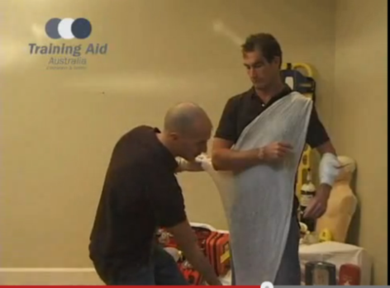 | 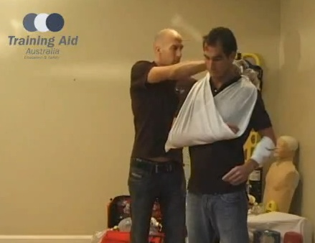 | 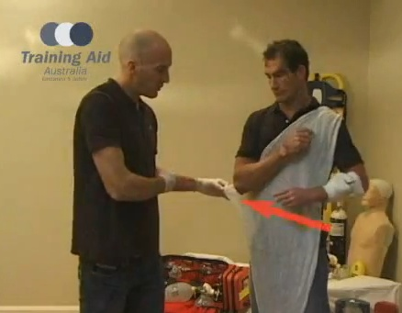
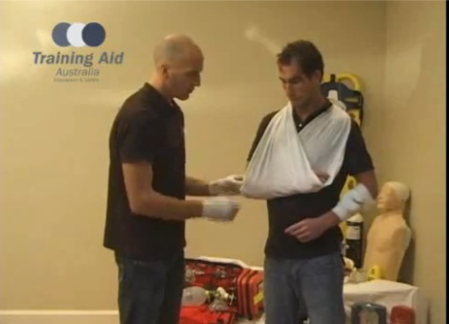 | 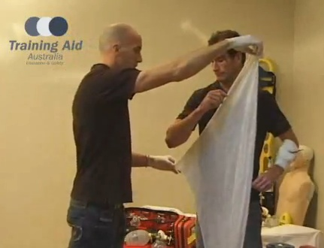 | 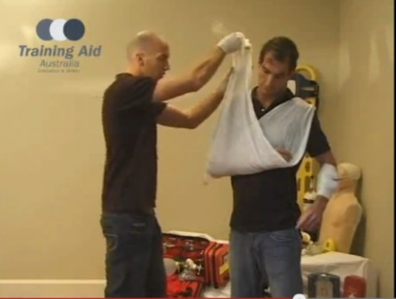

- Copy these words.

arm
body
sling
tie

Part B
- Follow these instructions:
- Watch the video clip that shows how to put on an arm sling. (Assessor or candidate to access clip at www.youtube.com/watch?v=C63rt-fleGY.)
- Listen while your assessor reads each statement.
- Arrange the statements below in the correct order.
- Match the statement to the correct picture (see Part A for pictures).
- Watch the video clip again to check that your order is correct.

Put the sore arm across the body | Tie the sling with a knot | Hold the bandage with the longest side pointing down to the ground
Make sure the elbow is covered by the sling | Lay the bandage across the body | Take the bottom of the sling and fold it over the other shoulder

- Follow these instructions:
- Fill in the missing words in the following text.
- Listen while your assessor reads the text and the missing words to you: wrist, arm, forearm, sling

- This video is about putting on an ___ _____. It is used for ____ and _____ injuries.

- Check your answers by watching the video clip again.

Part C
- Follow these directions to watch a video clip.

- Access the video clip at: www.youtube.com/watch?v=C63rt-fleGY.

- Watch the introduction and the first demonstration only. You may need to watch the video clip more than once, or you may want to stop the clip at different points during the demonstration.

- What is the name of the first sling demonstrated?

- What is this sling used for?

- Write a set of instructions for how to apply the sling:

- Demonstrate the application of the sling on your assessor using the material provided by your assessor. Explain what you are doing at each stage of the demonstration.

- Who do you think produced this video clip?

- Who might find this video clip useful?

