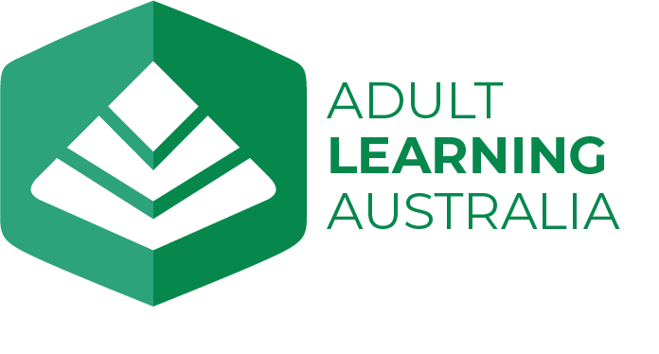

Media Release - Hot Picks for Summer

We asked some of our politicians, musicians, entertainers, Board and staff members for their hottest summer picks to read, watch and listen to over the summer break.

On the lookout for great holiday reads, shows, or tunes? Australia’s peak body for adult learning and community education, Adult Learning Australia (ALA), has asked some of our politicians, musicians, entertainers, Board and staff members for their hottest summer picks – and there are some rippers!
ALA CEO, Jenny Macaffer, said that continuing to learn through adulthood enhances wellbeing and keeps minds vibrant. Reading, watching and listening to a range of diverse materials sparks creativity and broadens perspectives. Sharing book recommendations, for instance, can encourage others to read and foster literacy development.
Developing good reading habits early is vital, so it is great to see Assistant Minister for Health and Aged Care, Ged Kearney, enjoying Fluff by Matt Stanton, with her grandchildren.
Jason Clare, Minister for Education, will be taking advantage of some quieter time to read Tom Holland’s Pax: War and Peace in Rome's Golden Age, while Treasurer, Jim Chalmers, recommends The Sun Will Rise, by Misha Zelinsky.
Sussan Ley, Deputy Leader of the Opposition will be feeding her interests in music, history and Australian storytellers by reading Faith Hope and Courage by Nick Cave and Seán O’Hagan and Question 7 by Richard Flanagan
Andrew Leigh, Assistant Minister for Employment, is also an author and a voracious reader. He passed on a list of recommendations but nominated Tomorrow, and Tomorrow, and Tomorrow by Gabrielle Zevin as his top pick.
David Bridie, multi-award-winning songwriter and composer, founding member of Not Drowning Waving and My Friend the Chocolate Cake recommends listening to Sorousian by Tio, a songwriter and singer from Vanuatu who is touring here in early 2024.
In between his ABC Friday Revues, performer, writer, producer and comedian, Brian Nankervis found time to read and love Tom Lake by Ann Patchett – a “beautiful family story, set in and around a cherry farm in Michigan”.
Brendan O'Connor, Minister for Skills and Training, SA Minister for Education, Training and Skills, Blair Boyer and ALA President Annette Foley are all making time to read David Marr’s Killing for Country: A Family Story over the summer.
Tony Burke, Minister for Employment and Workplace Relations and Minister for the Arts is looking forward to reading Jessica Au’s novel, Cold Enough for Snow, which won the 2023 Prime Minister’s Literary Award for Fiction.
Adam Bandt, Leader of the Australian Greens, recommends having some fun by watching Deadloch, reading Eleanor Catton's Birnam Wood and hosting your own dance party at home while listening to Mike Callander's mix at Revolver Upstairs on Soundcloud. His deputy, Mehreen Faruqi, is opting for a leisurely pace, catching up on the spy drama Slow Horses.
And Jenny Macaffer recommends Did I Ever Tell You This? A Memoir by Sam Neill – “delightful to read and hard to put down”. And she’ll be listening to David Bridie's album, The Wisdom Line.
Visit here for the full list.

Who is ALA?
Adult Learning Australia (ALA) is the largest national peak body for adult learning and community education (ACE). We are a not-for-profit entity that has been in operation for more than 60 years, with both organisational and individual members in all states and territories who reflect the diversity of the sector and promote lifelong learning for all.
Jenny Macaffer
Chief Executive Officer
Adult Learning Australia
P: 0488030073

Date
20 December 2024

