Read signs

Target core skills
This task covers ACSF:
- Learning, Reading and Writing at Pre Level 1
- Reading, Writing and Speaking at Level 1
- Reading at Level 2, and some evidence for Writing OR Speaking at Level 2 depending how questions 5 and 6 are delivered
- Reading at Level 3.

Target audience
This is a generic task that could be used in many workplaces.

Content coverage
The stimulus material for this task is workplace signs. It is a graded task that requires different processes ranging from matching and copying (Pre Level 1) to recognising (Level 1) to simple interpreting (Level 2). Although the signs don’t have a lot of words they are typical examples of texts that candidates in the workplace must recognise and interpret. The level 2 signs include less familiar words, e.g. caution, prevent, promote and requires the candidate to call on prior knowledge to interpret ideas and information provided in a succinct presentation.

Instructions to assessor
This task requires the candidate to:
- listen to the assessor who will read each question
- read a range of signs
- complete the various activities based on the signs.
This task is designed to be delivered orally. However, candidates who are able to complete questions 5 and 6 could write their responses if that is preferred. Ideally for Pre Level 1 it would be preferable to provide cards that the candidate can then match.
Ensure the candidate understands the task before commencing. Provide the appropriate support for the level. Conclude the task once you feel the candidate has reached their highest level of performance.
At level 2 you would expect the candidate to provide some explanation of the sign, e.g. Hazchem means hazardous chemicals/dangerous chemicals. In our workplace we use very strong chemicals to clean and these can be dangerous if they get in your eyes. An example of a hazardous/dangerous chemical in our workplace is bleach.
Please note: question 6 is designed for those candidates who may be able to demonstrate some evidence for Level 3 Reading. If the candidate successfully complete question 6 you may need to give them a Level 3 Reading assessment from the kit.

ACSF mapping
Question | ACSF skill level indicator | Domains of Communication
1 | Pre Level 1 Learning and Reading | Personal and community  Workplace and employment and/or  Education and training
2 | Pre Level 1 Learning, Reading and Writing
3 and 4 | 1.03 1.04
5 | 2.03 2.04  2.05 2.06 or 2.07
6 | 2.03 2.04 or 3.03 3.04  2.05 2.06 or 2.07

Read signs
- Draw a line between the sign and its meaning. The first one has been done for you.

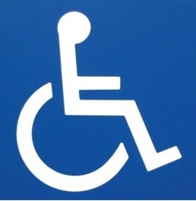 | Toilets
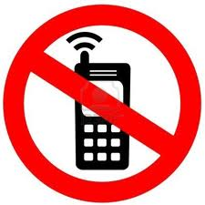 | No cars
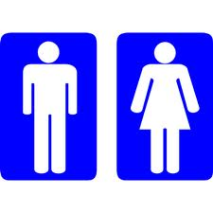 | Wheelchair
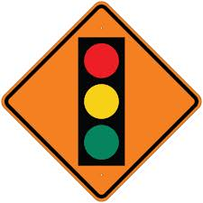 | No smoking
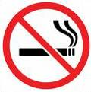 | No phones
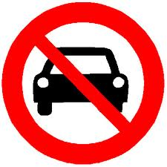 | Traffic lights

- Underneath these signs write what they mean. Copy the correct words from the table above.

________________ _________________ __________________

- Draw a line between the sign and its meaning.

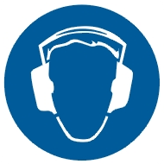 | Foot protection must be worn
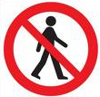 | No naked flames
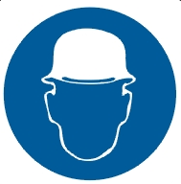 | Ear protection must be worn
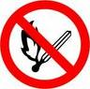 | Head protection must be worn
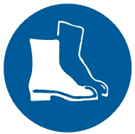 | No admittance

- Where would you find these signs?

- In your own words explain what these signs mean?

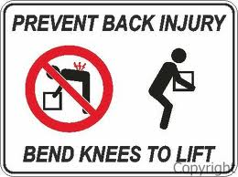 | __________________________________________
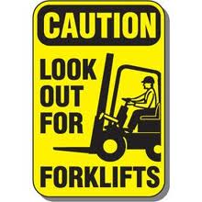
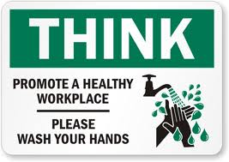

- Using the information on the sign below, answer the questions that follow.

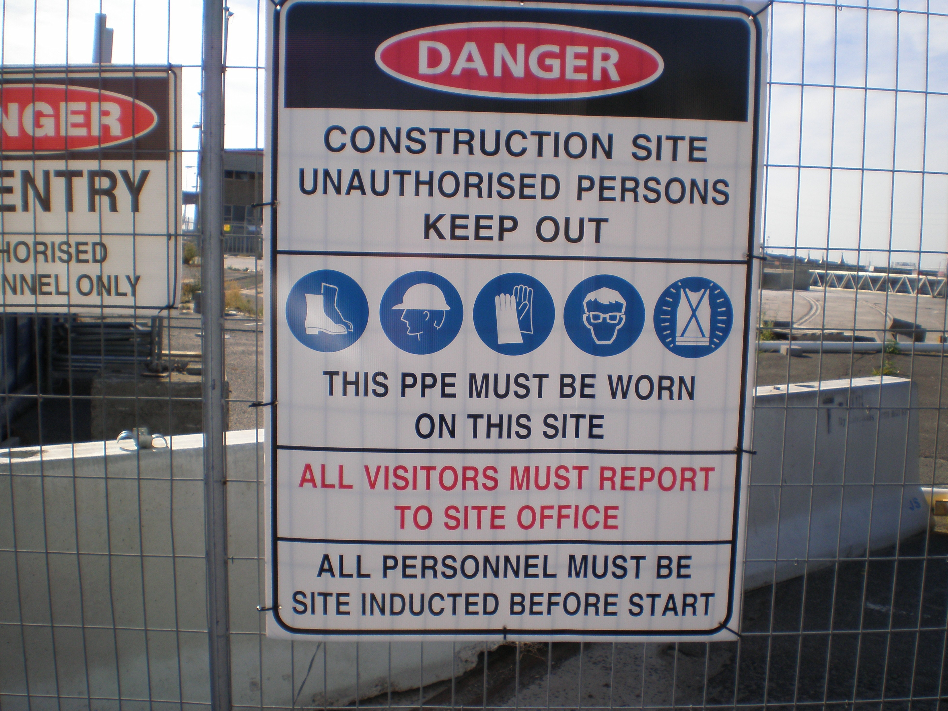

- Who is this sign for?

- Do you think this sign would be on the inside or the outside of the site? Where? Why?

- Why do all visitors need to report to the Site Office?

- What does PPE mean?

- Why do you think the following PPE items need to be worn?
safety vests

eye protection

- What do you think the site induction might include?

- Explain what you think the following terms mean?
all personnel

no unauthorised access

