Read a map

Target core skills
This task covers ASCF:
- Reading, Writing and Numeracy at Pre Level 1
- Reading, Oral communication and Numeracy at Level 1
- Numeracy at Level 2.

Target audience
This task is appropriate for a range of workplaces.

Content coverage
This task covers knowledge around using a simple map. As with a number of tasks at these low levels the stimulus can remain the same and the level of task complexity can alter by setting more difficult questions. You can replace the map with something similar that is local and alter the questions for relevance.

Instructions to assessor
Tasks at this level need to be delivered orally. The assessor needs to read the questions to the candidate. It is important that the candidate understands this type of text layout, and its purpose. The task enables the candidate to demonstrate evidence at Pre Level 1 and Level 1. Remember to adjust the level of support you provide for the different levels and to factor the level of support you provide into your final rating. Less support would be appropriate for questions 9 – 15 compared with questions 1 – 8. The direction and location aspects of questions 12 – 15 enable the candidate to demonstrate evidence for numeracy to Level 2 for the .10 indicator. Adjust the support required as appropriate and conclude the task once you feel the candidate has reached the highest level of their performance.
Cut up the words in question 8 in preparation for the task.

ACSF mapping
Question | ACSF skill level indicator | Domains of Communication
1 - 4 | Pre Level 1 Reading, Writing | Personal and community,  Workplace and employment and/or  Education and training
5 - 6 | Pre Level 1 Reading, Writing, Numeracy
7 - 8 | Pre Level 1 Reading, Writing
9 - 10 | 1.04 1.06 1.10
11 | 1.04 1.07 1.09
12 - 15 | 1.04 1.06 2.10

Read a map
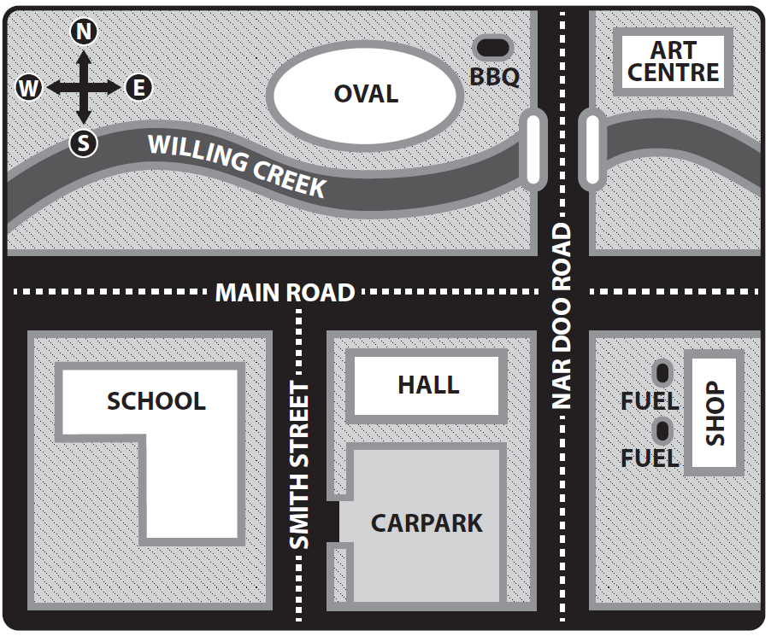

Answer the following questions about the map above.

Choose the correct words from the information in the map.

- The creek is called ____________________________ Creek.

- The BBQ is near the _______________________.

- The oval is next to the ___________________________.

- The bridge over Willing Creek is on ____________________ Road.

- The shape of the shop is a ___________________________. (circle, square, rectangle)

- The hall is _________________________ than the school. (bigger, smaller)

- Use the words on the map to help you to fill in the missing letters in the following words.

Str_ et _ illing Cen_re N_rdoo

- Place the following cards (once cut up) on top of the feature on the map.

School | BBQ | Fuel pump
Hall | Shop | Carpark
Oval | Creek | Smith Street

- The school is an __________________________ shaped building (T, L)

- The fuel pumps are on the _____________________ side of the shop. (west, east, north)

- Give instructions for how you would get from the carpark to the oval, by car.

- The oval is _____________________________ of the hall. (east, north, west)

- The Art Centre is __________________________ of the oval. (west, east, south)

- If you were driving east along Main Road you would turn _________________ into Smith St to get to the carpark. (left, right)

- If you were driving south on Nardoo Road you would turn ____________ to get to the school. (left, right)

