Making numbers work 1

Target core skills
This task covers ACSF Numeracy at Pre Level 1, Level 1 and will provide some evidence for Numeracy Level 2.
Making numbers work is in two parts. This first part focuses on ACSF Pre Level 1 and Level 1. Part 2, titled Making numbers work 2 focuses on ACSF levels 2 and 3.

Target audience
This task is suitable for a range of workplaces.

Content coverage
This is a generic numeracy task covering a range of mathematical knowledge and skills including number and algebra, measurement and geometry and statistics and probability. The task is really useful to get a good idea about a candidate’s numeracy level.
On its own this task is not comprehensive enough to provide more than a ballpark assessment of the candidate’s numeracy level. Assessors would be wise to confirm any levels from this task with another industry specific task. It can also be used to confirm a numeracy level that may have been demonstrated in another tool in the bank, but where more evidence needs to be demonstrated in order to be confident in your rating.
Questions 10 and 11 have been rated at level 1. However, for some candidates digital time is so familiar that this activity may not provide evidence at level 1.

Instructions to assessor
- This task is aimed at candidates who are operating a Pre Level 1 or Level 1. It is important that the assessor reads the questions to the candidate it be delivered so as not to rely on the candidate’s reading skill. This will also allow for the collection of evidence for the .11 indicator. It may assist candidates if cards are provided for activities such as those in questions 1, 2, 5, 6 and 7, and real money for questions 8 and 9.
- A few questions have been aimed at eliciting evidence at Level 2. This enables a candidate to demonstrate their highest level of performance. If the candidate does perform well on these questions it might be advisable to give them some questions from Making Numbers Work 2 which is focussed on ACSF levels 2 and 3 in order to fully assess their numeracy skills.
- Don’t forget to alter the level of support depending on the level of the question. If for example a candidate is able to complete some level 1 questions but only with significant support, then your rating needs to reflect this.
- Remember to ask the candidate to show their workings for those questions where it is indicated in the instructions. This will allow you to gain some evidence for the .11 indicator.

ACSF mapping
Question | ACSF skill level indicator | Domains of Communication
1 - 8 | Pre Level 1 Numeracy | Personal and community,  Workplace and employment and/or  Education and training
9 | 1.09 1.10 1.11
10 - 11 | 1.09 1.10 1.11
12 - 13 | 1.09 1.10 1.11
14 - | 2.09 2.10
15 | 2.09 2.10 2.11
16 | 2.09 2.10 2.11
17 - 19 | 2.09 2.10 2.11

Making numbers work 1
- Underneath these pictures write the correct name of the symbol. Choose from triangle, square, rectangle or circle.

- What shape are these signs? Choose from triangle, square, rectangle or circle. The first one has been done for you

circle
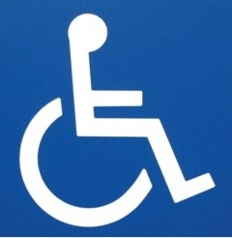

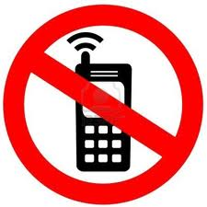

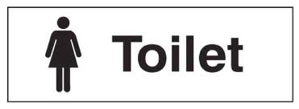

- Circle the smallest number in the following groups

21 5 38

62 47 74

- Circle the biggest number in the following groups

37 17 27

85 89 81

- Arrange the following pictures in order from the one with the smallest number of red dots to the one with the biggest number of red dots.

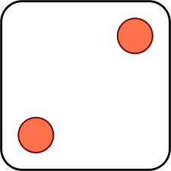Picture 1 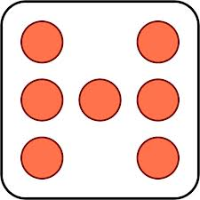Picture 2

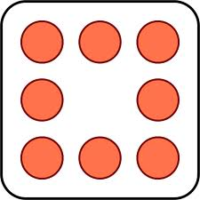Picture 3 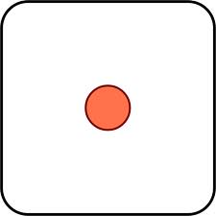Picture 4

_______________ _______________ _______________ _______________

- Match the following numbers on the left with the correct word in the right. The first one has been done for you.

3 | two
6 | four
2 | eight
8 | three
4 | seven
7 | six

- Put the following words/cards in order from first to tenth. The first and last ones have been done for you.

third | ninth | fourth | first | seventh | second | eighth | fifth | tenth | sixth
first |  |  |  |  |  |  |  |  | tenth

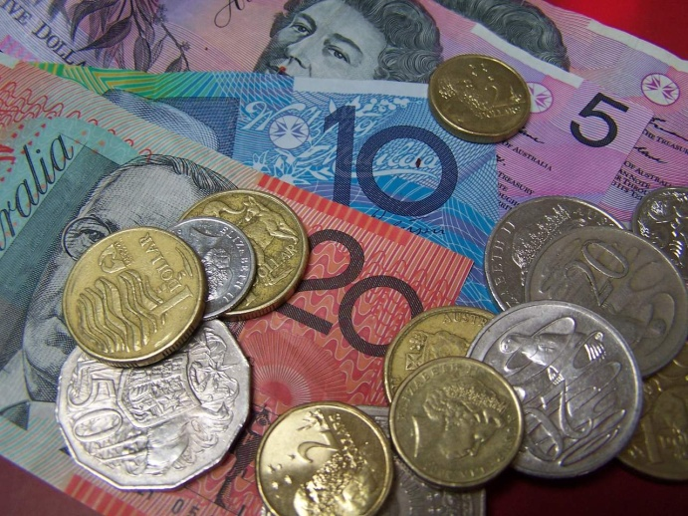

- What Australian coins can you see in the picture above? Point to the coins and say their value.

- What Australian notes can you see in the picture above? Point to the notes and say their value

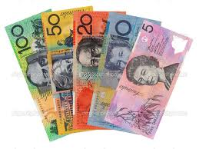
Use your calculator to work out the total value of these notes.

Total value: __________

- Draw the times on the clock faces for the following digital times. The first one has been done for you.

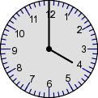 | 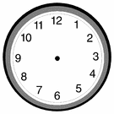
4:00 | 1:15 | 6:30 | 11:45

- Write these times on the following clock faces. The first one has been done for you.

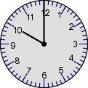

Ten o’clock | Half past four | Quarter to two | Quarter past eight

- Can you tell me how to get from this room to the canteen? Try to give approximate distances (in steps) and use the terms ‘left’ and ‘right’ where needed.

- The table below shows how many boxes of apples, bananas, grapes and oranges were sold by Greens Fruit Shop in December 2013.

60
50
40
30
20
10
Apples Bananas Grapes Oranges

- What was the most popular fruit sold by Greens during December 2013?

- What was the least popular fruit sold by greens during December 2013?

- Did Greens sell more apples or oranges in December 2013?

- Circle the correct answer. Greens sold half as many grapes as:

Apples Bananas Oranges

- Each box of oranges holds 50 oranges. How many oranges did Greens sell in December 2013?

- In November 2013 Greens sold 10% fewer apples than in December. How many boxes of apples did they sell in November? Can you mark this on the table in question 13?

- The following table shows the normal price and the closing down sale price for a range of goods at Top Shelf Office Supplies.

TOP SHELF OFFICE
Item | Normal Price $ | Closing Down  Sale Price $
Lap Top Computers | 1500.00 | 1000.00
Top Quality Paper (Box) | 26.00 | 13.00
Desk Chairs | 155.00 | 100.00
Filing Cabinets | 80.00 | 60.00
Blank CDs (box of 20) | 40.00 | 32.00

Use the information from the table to answer the following questions. Show how you worked out your answers without using a calculator.

- What is the difference in dollars between the normal price and the sale price for the desk chairs?

- You buy one computer and two boxes of paper at the sale price. What is the total that you will pay?

- How much would two filing cabinets cost at the normal price?

- You purchase two computers at the sale price. How much have you saved on the normal price?

- What is the percentage (%) saving of the filing cabinets in the sale? Show your working out.

- How much change would you get from $500.00 if you purchase the following items. Show your working out.
- Two boxes of paper

- 40 blank CDs

- One desk chair

- If the computers are reduced by a further 10% what will the new price be? Show your working out.

