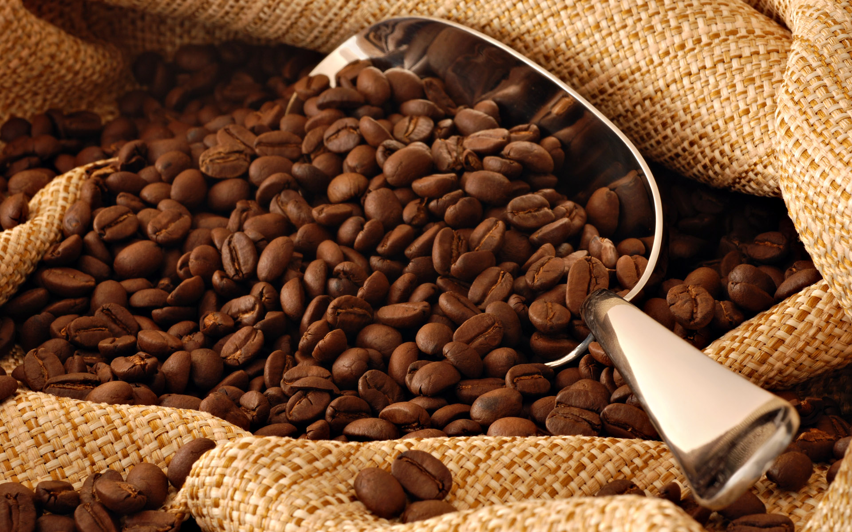
Coffee – choose it, buy it, make it, enjoy it

Focus is:
Assessment of an ‘exit’ 1 and assessment of two different indicators in one assessment process.

What is this?
This example uses the theme of coffee because of its universality and the variety it offers teachers and assessors. It deliberately moves from ACSF Level 1 and 2 in case you have learners with mixed levels in your class. You could substitute other universal themes, like tea, water, cola, rice, noodles, bread and use this format.
You may also decide that you don’t need questions 9 and 10 because the first 8 questions give sufficient capacity for the learners to demonstrate their reading skills of the indicators at ACSF 1.

ACSF skill indicator and levels
Skill area | Reading | Focus areas | Text navigation (1.04, 2.04), comprehension strategies (1.04, 2.04), decoding and fluency (2.04), syntax and language patterns (2.04)
 |  |  | Purpose (1.03), complexity, prediction and prior knowledge, text analysis

Level of support for this indicator and level
1.04: Expert mentor to provide prompting and advice (p. 51).
2.04: Mentor to offer support if requested (p. 55).

Anything to be aware of with this activity
If you’re working in the Skills for Education & Employment (SEE) program, you will be aware that you have to report an indicator outcome every 100 hours. At the time of writing, the SEE program’s Independent Verifiers have no objection to an assessment being presented and claimed at separate 100-hour blocks. So, you could report the first indicator – 03 – at a hundred-hour interval and the second – 04 – indicator at the next hundred-hour interval. You probably already know that with the SEE program you are required to have two separate examples for each indicator and level, so planning ahead and storing learners’ work in their portfolio will help you, even if it is time-consuming.
You’re not assessing numeracy, so explain the ‘percentage’ question fully. The question is really about learner’s ability to sense that ‘coffee ain’t all coffee’, not to get a numeric answer.

Material preparation for the lesson/assessment
If you have access to a data-projector, put the pictures of the labels up on a screen. It will save a lot of ink. If not, consider making a couple of copies of the label pictures and share them between two or three learners. Students working cooperatively with you as mentor to support – is reasonable at both levels of the ACSF.
If you have a recently arrived group – and access to petty cash – buy one of each of the items used for the assessment and take into class – it will help the low level learners, especially, to look at the real thing. In case this isn’t possible: the ingredients and instructions are listed below, with the internet texts reproduced here as well (they are also on the learners’ worksheets. To provide them to ‘read and ask for help with new words’ – consistent with support offered for Levels 1 and 2).

Labels
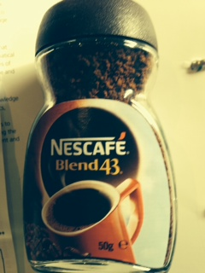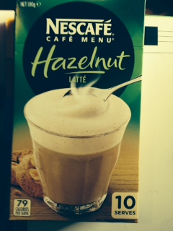

Ingredients/instructions
Instant coffee 50g jar | Hazelnut Latte pack of 10
Ingredients:  Coffee | Instructions:  Sugar  Milk solids  Vegetable oil  Soluble coffee (9%)  Maltodextrin  Stabilizers (340, 452, 331)  Salt  Anti-caking agent (551)  Flavour  Contains milk
Instructions:  Nil | Instructions:  Empty the contents of a stick into your favourite glass  Pour 150 ml (2/3 of a glass) of hot, not boiling water, and give it a good stir  ENJOY your deliciously frothy coffee

Internet texts
- Ingredients must be listed in descending order (by ingoing weight). This means that when the food was manufactured, the first ingredient listed contributed the largest amount and the last ingredient listed contributed the least. For example, if sugar is listed near the start of the list the product contains a greater proportion of this ingredient.
http://www.foodstandards.gov.au/
- 2WBT's experts suggest that women eat 1200 calories a day and men eat 1800 a day when they're trying to lose weight. For women, that means three 300-calorie meals and a total of 300 calories in snacks (or drinks) during the day, whereas for men meals can be 450 calories each, with snacks adding up to 450 in total.
Adapted from https://www.12wbt.com/nutrition/how-many-calories/lose-weight
C.
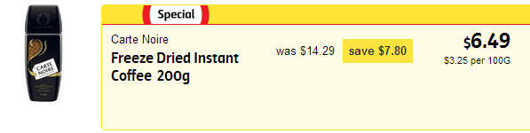
http://shop.coles.com.au/online/national/specials

What else could you do with this activity?
- Discuss the words ‘packet’ and ‘sachet’ why are they pronounced differently*? Are there other words the class can think of with influences from French pronunciation? For example:
(*http://www.etymonline.com/ tells us that ‘packet’ came into English in the mid-15th Century, sachet arrived into English in the mid-18th Century. They both derive from ‘little’ i.e. little pack and little sac. )
- Go to: www.fatsecretaustralia.com.au and get the learners to compare pre-packaged latte drinks with plain coffee and its calorific implications.
- Why do advertisers/producers choose words from another language, like ‘latte’ (Italian for milk) and ‘carte noire’ (French for black card or black label).
- If your group comprises ESL learners, ask them about ‘cool’ English words in their language.
- Make a list of non-English words the learners know.
- For literacy classes: what do those numbers on the label mean -–what are those additives?
- Go to http://www.mbm.net.au/health/500-585.htm or http://www.foodstandards.gov.au/consumer/additives to explore.

Learner worksheets

Your name: ____________________ Today’s date: ___/___/___

What to do
We’re going to look at coffee, packaged and sold two ways. One is a jar of Nescafe Instant Coffee.
The second is a packet of Nescafe Hazelnut Latte-Mix sachets.
- Look at both front labels.
- Can you read how many cups of coffee you can get from the packet of Hazelnut Latte?
Yes / No ________________
- Can you read how many cups of coffee you can get from the jar of Nescafe?
Yes / No ________________
- Can you read how many grams of coffee each pack contains?
Yes / No ________________
- Can you read how many calories each pack contains?
Yes / No ________________

- All these words are on the packet of the Latte sachets. Read each one and them copy them into the ‘instructions’ or ‘information’ column. The first two are done to help you.
– made from – taste-delicious – pour – empty – stir

Instructions – how to make the drink | Information to make you want the drink
Stir | Made from

- Look at the instructions and the pictures from the side of the packet.
- The pictures don’t match the writing. Can you draw a line to make each picture match?
Empty the contents of the stick into a glass or cup. | Picture 1
Stir in some hot water. | Picture 2
ENJOY the coffee drink  – it’s ready now. | Picture 3

- Why is ‘enjoy’ in capital letters?

_______________________________________________

- Look at both sides of the jar of instant coffee … does it tell you how to make coffee?
Yes / No

- Why does one pack of coffee tell you how to make it and one doesn’t? Discuss this with your class and write the best answer here.

- Look closely at both the coffee containers for information on ‘ingredients. What’s the percentage of coffee in each?

In the jar of coffee | In the packet of Hazelnut Latte

- From what you know about making instant coffee, read these instructions and tick the best one.

1. | - Put 1 or 2 spoons of coffee into a cup.  - Pour cold water into the cup.  - Stir the coffee to mix it with the water  - Add sugar and milk, if you like.
2. | - Put 1 or 2 spoons of coffee into a cup.  - Pour boiling milk into the cup.  - Stir the coffee to mix it with the water  - Add sugar and water, if you like.
3. | - Put 1 or 2 spoons of coffee into a cup.  - Pour boiling water into the cup.  - Stir the coffee to mix it with the water  - Add sugar and milk, if you like.
4. | - Put 1 or 2 grams of coffee into a cup.  - Pour boiling water into the cup.  - Stir the coffee to mix it with the water  - Add sugar and milk, if you like.

The best instructions are number ________________

- What is wrong with the other instructions? Put some circles around the mistakes or tell your teacher what’s wrong.

- Read these three pieces of information from three different websites. Ask for help with any new words.

- Ingredients must be listed in descending order (by ingoing weight). This means that when the food was manufactured, the first ingredient listed contributed the largest amount and the last ingredient listed contributed the least. For example, if sugar is listed near the start of the list the product contains a greater proportion of this ingredient.
http://www.foodstandards.gov.au/
- 2WBT's experts suggest that women eat 1200 calories a day and men eat 1800 a day when they're trying to lose weight. For women, that means three 300-calorie meals and a total of 300 calories in snacks (or drinks) during the day, whereas for men meals can be 450 calories each, with snacks adding up to 450 in total.
Adapted from https://www.12wbt.com/nutrition/how-many-calories/lose-weight
C.
http://shop.coles.com.au/online/national/specials

Now read about these four people and write the letter of the website next to each one, to show where they got their information. The first one is done to help you.
SAMPLE
Hazel really enjoys Nescafe’s Hazelnut Latte coffee mix. But she knows it’s very sweet. She read the ingredients and realised that it has more sugar than coffee in it. Now, she only drinks one per day.
Hazel got this information from Website : -A-
Henry is a jobseeker and he manages his New Start allowance very carefully. He tries to buy everything on special, so he’s happy to find out that ‘Carte Noire’ is more than 50% off this week.
Henry got this information from Website ___________
Harriet wants to know that her food is not making her fat. She drinks coffee, with no milk and no sugar. She knows if she keeps the sugar and milk down she’s not ‘over-snacking’.
She got this information from reading Website ______________
Harry was surprised to discover that in Hazelnut Latte, coffee drink, there is less coffee than:
- Sugar
- Powdered Milk – ‘milk solids’
- Oil
Harry got this information about the amounts of ingredients from
looking at Website _________
- Look at these words. Underline the syllable is the most-emphasised. The first one is done to help you.
- favourites
- ingredients
- hazelnut
- information
- nutrition

Answer grid and links to ACSF indicators
 | Questions | Answers/sample answers | Performance features 1.03 / 2.03 | Performance features 1.04 / 2.04 | NB
1. | Look at both front labels. Can you read…? | - yes  - no  - no – only the jar tells you the quantity  - no – only the box tells you about calories | Text analysis 1 | Text navigation 1
2. | All these words are on the packet of the Latte sachets. Read each one and them copy them into the ‘instructions’ or ‘information’ column. | Instructions:  stir  pour  empty  Information:  made from  delicious  taste | Text analysis 1  Complexity 1 | Text navigation 1  Comprehension strategies  1  Vocabulary
3. | - Look at the instructions and the pictures from the side of the packet. The pictures don’t match the writing. Can you draw a line to make each picture match?  - Why is ‘enjoy’ in capitals? | Pic 1 – Empty the stick into a cup  Pic 2 – Stir in hot water  Pic 3 – ENJOY the drink.  Sample answer: ‘because the drink will taste nice, you will enjoy it.’ | Purpose 1  Complexity 1  Text analysis, Critical reading. 2 | Text navigation 1.  Comprehension strategies  1  Vocabulary – words can have more than one meaning ( although enjoy is not really an ‘instruction) 2 | NB – discuss as a group Q. 3 b about ENJOY) if you are not assessing for level Write a group answer after discussion. With some groups, this might lead to a discussion on advertisers’ tricks.
4. | Look at both sides of the jar of instant coffee…does it tell you how to make coffee | No. | Purpose 1  Critical reading and Text analysis 1 | Text navigation 1
5. | Why does one pack of coffee tell you how to make it and one doesn’t | Sample answer:  Because most people know how to make coffee when they buy it | Prediction and prior knowledge | n/a
6. | Look closely at both the coffee containers for information on ‘ingredients. What’s the percentage of coffee in each? | - Jar – 100% coffee  - Latte-Mix – 9% coffee | Purpose, complexity 1 | Text navigation 2 | If you’re working with learners with relatively little formal education, you may need to remind them about percentages and what 100% means.
7. | From what you know about making instant coffee, read these instructions and tick the best one | Instructions number 3 is the best answer | Purpose 1  Complexity1  Prediction and prior knowledge 1 | Text navigation 1  Comprehension strategies 1 (if you observe them slowly reading and re-reading) | If your learners are new to Australia, you may decide to practise making coffee in the student kitchen, first, to instill their prior knowledge.
8. | What is wrong with the other instructions? Put some circles around the mistakes or tell your teacher what’s wrong | 1 – Pour cold water  2 – Pour boiling milk  4 – 1 or 2 grams of coffee | Text Analysis1  Complexity 1  Critical Reading1 | Text navigation 1 Syntax and language patterns – begins to use surrounding words … | As with the latte-mix instructions, you might have a class discussion about why not to boil milk for coffee (– possible reason: in case it turns sour)
9. | Read about these four people and write the number of the website …to show where they got their information. | 2 – C  3 – B  4 – A | Purpose 2  Complexity 2  Text Analysis 2 | Comprehension strategies 2  Text navigation 2  - Begins to skim and scan
10. | Look at these words. Underline syllable is the most-emphasised. | - favourites  - ingredients  - hazelnut  - information  - nutrition |  | Decoding and fluency 2

